**Technical Design document for Blue Prism Real time Reporting**

**Version 1.1**

Version: 1.1 Draft

Prepared by: Rajesh R Nair

Contents

TDD Document Details 2

Revision History 2

Approvals 2

Introduction 3

Purpose 3

Solution Architecture 3

Reports 4

Appendix 6

## TDD Document Details

|  |  |
| --- | --- |
| **Document:** | Blue Prism Realtime Reporting Design document |
| **Document Name:** | Blue Prism Realtime Reporting Design document.docx |
| **Author:** | Rajesh R Nair |
| **Last Updated:** | 14-Mar-2019 |
| **Version:** | 1.1 |

## Revision History

|  |  |  |  |  |
| --- | --- | --- | --- | --- |
| Date | Version # | Summary of Changes | Author | Comments |
| 14-Mar-2019 | 1.0 | Initial version | Rajesh R Nair |  |
| 22-Mar-2019 | 1.1 | Updated for Use Case 3 | Rajesh R Nair |  |
| 30-Mar-2019 | 1.2 | Updated for Use Case 4 | Arya Ratheesh |  |
| 8-Apr-2019 | 1.3 | Updated for Use Case 2 | Arya Ratheesh |  |

## Approvals

|  |  |  |
| --- | --- | --- |
| Name | Role | Date Approved |
|  |  |  |
|  |  |  |
|  |  |  |
|  |  |  |

1. Introduction

Blue Prism Digital Exchange (DX) is a business process automation tool which interacts with systems in place in MetLife to track VDI resource details, session states and process termination status and the data stored in SQL Server 2106.

There are 4 real time reports to be built for a second channel to visualize the information better and faster than the tool Blue Prism provide.

## Purpose

The purpose of the document is to design a real time reporting platform from Blue Prism with 10 seconds refresh rate. The requirement is to build 4 real time reports are described as below

|  |  |
| --- | --- |
| Use Case no. | Report Name |
| Use Case 1 | VDI State (Offline/Working/Idle) |
| Use Case 2 | Schedule |
| Use Case 3 | Stage Started |
| Use Case 4 | Terminations Watchers |

## Solution Architecture



* 1. Source Layer

The Source Layer would be the Blue Prism database in SQL Server 2016 and the row data will be fetched from the source Layer with the query provided by Metlife.

* 1. Real Time

Power BI will connect to the Streaming data sets with the History analysis enabled which ensures data is stored in SQL source database and query used to transfer the data in real time. The Logical flow of Powershell script is as below.

* Set the Connection with the SQL Server with SQL Connection object
* Set the Query with the command object
* Execute the query with ExecuteReader
* Read the data from SQL server and POST it to the Data stream dataset end point for the corresponding report
* Sleep for 10 sec and refresh the data again

The Powershell script will be called by MetLife approved scheduler tools such as Maestro/Windows scheduler.

* 1. Gateway

Power BI report files and model (with data sets and source connections) are published to Power BI Cloud service (https://app.powerbi.com) over MetLife Azure Tenant. Here, Gateway acts as an intermediary layer for secure data transfer between on premise and cloud. Since the stream dataset is used to refresh the report the gateway is not leveraged in these reports. The Gateway is not used in the current architecture as the data will be pushed to the stream dataset with Powershell scripts.

* 1. Security

Power BI access uses Office 365 login accounts for authentication, once Office 365 admin has assigned Power BI license to respective users. .

* 1. Architecture Considerations
* Feature not enabled for report access to SharePoint Online
* External users would not be able to access Cloud workspace and would not be able to publish their own reports.
* External users require a Pro License to access reports, which are not in premium node.
* The 10 sec refresh is possible only when the all 4 use cases would return data within 10 seconds.

## Reports

There are 4 Real time reports with 10 sec refresh interval to be generated and the report specifications are provided as below.

1. VDI State (Offline/Working/Idle)

This captures the Bot state along with which resource is belongs to. This information allows Metlife to take action to see why a bot is not working. The core driver of this report is the number of VDIs in Metlife platform

* 1. Query

|  |
| --- |
| ;with DP AS  ( Select 'Idle' AS DisplayStatus  UNION ALL Select 'Logged Out' AS DisplayStatus  UNION ALL Select 'Missing' AS DisplayStatus  UNION ALL Select 'Offline' AS DisplayStatus  UNION ALL Select 'Private' AS DisplayStatus  UNION ALL Select 'Working' AS DisplayStatus  )  Select VDI.Name,VDI.Status,DP.DisplayStatus,VDI.ResourceGroupPool  from DP  Left Join (  SELECT VDI.name AS Name, VDI.status AS Status,VDI.DisplayStatus,CASE  WHEN GROUP_RESOURCE.groupname = 'Default' THEN VDI_POOL.PoolName  ELSE GROUP_RESOURCE.groupname  END AS ResourceGroupPool  FROM (SELECT [resourceid]  ,[name]  ,[status]  ,[processesrunning]  ,[actionsrunning]  ,[lastupdated]  ,[AttributeID]  ,[pool]  ,[DisplayStatus]  FROM BPAResource WITH (NOLOCK)  WHERE AttributeID = 0) AS VDI  LEFT JOIN  (SELECT resourceid AS PoolId, name AS PoolName  FROM BPAResource WITH (NOLOCK)  WHERE AttributeID = 8) AS VDI_POOL ON VDI.[pool] = VDI_POOL.PoolId  LEFT JOIN (SELECT [id],  [groupname]  FROM [BPVGroupedResources] WITH (NOLOCK)) GROUP_RESOURCE ON VDI.resourceid = GROUP_RESOURCE.id  WHERE  (GROUP_RESOURCE.groupname = 'Default' AND VDI_POOL.PoolId IS NOT NULL)  OR  (GROUP_RESOURCE.groupname <> 'Default')) VDI ON DP.DisplayStatus=VDI.DisplayStatus  WHERE VDI.ResourceGroupPool <> '__UnGrouped and UnPooled VDIs'    UNION ALL  SELECT '#*NA*#' as Name, '#*NA*#' as Status, '#*NA*#' as DisplayStatus, '#*NA*#' as ResourceGroupPool  ORDER BY ResourceGroupPool |

* 1. Report Layout

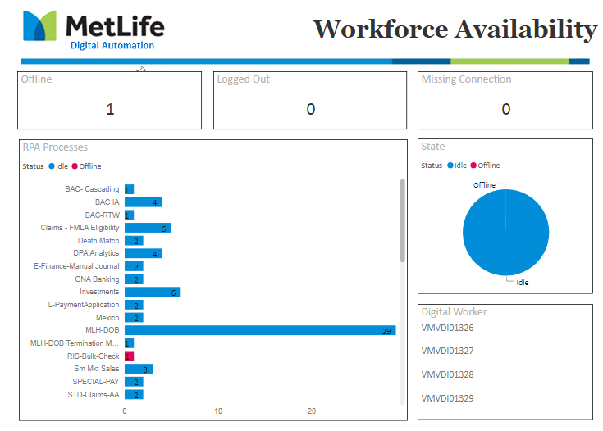

1. Schedule

Captures if a process scheduled kicks off on time. Useful information with this is to show the process, time to start the schedule, the last time ran and stopped, along with schedule details of its run intervals. Indicators inform user if a schedule did not kick off on time.

* 1. Query

|  |
| --- |
| SELECT ScheduleName ,  NextStarted ,  InstanceTime ,  TriggerPeriod ,  ConvertedUnit ,  StartPoint ,  EndPoint ,  CASE  WHEN convertedunit='Minutes'  AND CONVERT(VARCHAR(10), getdate(), 121) + ' ' + RIGHT(nextstarted, 7) <= CONVERT(VARCHAR(10), getdate(), 121) + ' ' + endpoint  AND CONVERT(VARCHAR(11), nextstarted, 121) = CONVERT(VARCHAR(11), instancetime, 121) THEN  CASE  WHEN (  Datediff(mi, instancetime, nextstarted)/triggerperiod)-1 <= 0 THEN 0  ELSE (Datediff(mi, instancetime, nextstarted) /triggerperiod)-1  END  WHEN convertedunit='Minutes'  AND CONVERT(VARCHAR(10), getdate(), 121) + ' ' + RIGHT(nextstarted, 7) > CONVERT(VARCHAR(10), getdate(), 121) + ' ' + endpoint THEN 0  WHEN convertedunit='Hours'  AND CONVERT(VARCHAR(10), getdate(), 121) + ' ' + RIGHT(nextstarted, 7) <= CONVERT(VARCHAR(10), getdate(), 121) + ' ' + endpoint  AND CONVERT(VARCHAR(11), nextstarted, 121) = CONVERT(VARCHAR(11), instancetime, 121) THEN  CASE  WHEN (  Datediff(hour, instancetime, nextstarted)/triggerperiod)-1 <=0 THEN 0  ELSE (Datediff(hour, instancetime, nextstarted) /triggerperiod)-1  END  WHEN convertedunit='Hours'  AND CONVERT(VARCHAR(10), getdate(), 121) + ' ' + RIGHT(nextstarted, 7) > CONVERT(VARCHAR(10), getdate(), 121) + ' ' + endpoint THEN 0  ELSE 0  END RiskScore ,  CASE  WHEN initialtaskid= 0 THEN 'TURNED OFF'  END ScheduleStatus  FROM (  SELECT schedulename,  next nextstarted ,  instancetime ,  triggerperiod ,  initialtaskid ,  startdate ,  convertedunit ,  startpoint ,  endpoint  FROM (  SELECT a.schedulename,  initialtaskid,  startdate,  CASE  WHEN convertedunit='Minutes'  AND getdate() BETWEEN CONVERT(datetime,(CONVERT(varchar(10), getdate(), 121) + ' ' +startpoint)) AND CONVERT(datetime, CONVERT(varchar(10), getdate(), 121) + ' '+ convertedendpoint)  AND dateadd(mi, triggerperiod, getdate()) < (CONVERT(varchar(10), getdate(), 121) + ' '+ convertedendpoint) THEN -- CONVERTedUnit='Minutes' and datediff(ss,convert(datetime,(convert(varchar(10),getdate(),121) + ' '+ StartPoint)),getdate())>=0 and datediff(ss,convert(datetime,(convert(varchar(10),getdate(),121) + ' '+ CONVERTedENDPoint)),getdate())<0 then  CONVERT(varchar,dateadd(mi, ceiling((datediff(ss, CONVERT(datetime,(CONVERT(varchar(10), getdate(), 121) + ' '+ startpoint)), getdate())/(1.0*triggerperiod*60))) * triggerperiod, CONVERT(datetime,(CONVERT(varchar(10), getdate(), 121) + ' '+ startpoint))), 100)  WHEN convertedunit='Minutes'  AND datediff(ss, getdate(), CONVERT(datetime,(CONVERT(varchar(10), getdate(), 121) + ' '+ startpoint))) >0 THEN -- and datediff(ss,getdate(),convert(varchar(10),getdate(),121) + ' '+ CONVERTedENDPoint) >0 THEN  CONVERT(varchar,CONVERT(datetime, CONVERT (varchar(10), getdate(), 101) + ' ' + startpoint), 100)  WHEN convertedunit='Minutes'  AND datediff(ss, getdate(), CONVERT(datetime,(CONVERT(varchar(10), getdate(), 121) + ' '+ convertedendpoint))) <0  OR (  dateadd(mi, triggerperiod, getdate()) > (CONVERT(varchar(10), getdate(), 121) + ' '+ convertedendpoint)) THEN CONVERT(varchar,CONVERT(datetime, CONVERT (varchar(10), dateadd(dd, 1, getdate()), 101) + ' ' + startpoint), 100)  WHEN convertedunit='Hours'  AND getdate() BETWEEN CONVERT(datetime,(CONVERT(varchar(10), getdate(), 121) + ' ' +startpoint)) AND CONVERT(datetime, CONVERT(varchar(10), getdate(), 121) + ' '+ convertedendpoint)  AND dateadd(hh, triggerperiod, getdate()) < (CONVERT(varchar(10), getdate(), 121) + ' '+ convertedendpoint) --and datediff(ss,convert(datetime,(convert(varchar(10),getdate(),121) + ' '+ StartPoint)),getdate())>=0 and datediff(ss,convert(datetime,(convert(varchar(10),getdate(),121) + ' '+ CONVERTedENDPoint)),getdate())<0 --and dateadd(hh,triggerperiod,getdate()) < (convert(varchar(10),getdate(),121) + ' '+ CONVERTedENDPoint)  THEN CONVERT(varchar,dateadd(hour, ceiling((datediff(ss, CONVERT(datetime,(CONVERT(varchar(10), getdate(), 121) + ' '+ startpoint)), getdate())/(1.0*triggerperiod*3600))) * triggerperiod, CONVERT(datetime,(CONVERT(varchar(10), getdate(), 121) + ' '+ startpoint))), 100)  WHEN convertedunit='Hours'  AND datediff(ss, getdate(), CONVERT(datetime,(CONVERT(varchar(10), getdate(), 121) + ' '+ startpoint))) >0 THEN -- and datediff(ss,getdate(),convert(varchar(10),getdate(),121) + ' '+ CONVERTedENDPoint) >0 THEN  CONVERT(varchar,CONVERT(datetime, CONVERT (varchar(10), getdate(), 101) + ' ' + startpoint), 100)  WHEN convertedunit='Hours'  AND datediff(ss, getdate(), CONVERT(datetime,(CONVERT(varchar(10), getdate(), 121) + ' '+ convertedendpoint))) <0  OR (  dateadd(hh, triggerperiod, getdate()) > (CONVERT(varchar(10), getdate(), 121) + ' '+ convertedendpoint)) THEN CONVERT(varchar,CONVERT(datetime, CONVERT (varchar(10), dateadd(dd, 1, getdate()), 101) + ' ' + startpoint), 100)  WHEN convertedunit='Days'  AND datediff(ss, CONVERT(datetime,(CONVERT(varchar(10), getdate(),121) + ' '+ right(convert(varchar(30),startdate,121),12))), getdate()) >0 THEN CONVERT(varchar(30), dateadd(day, 1, CONVERT(datetime,(CONVERT(varchar(10), getdate(),121) + ' '+ right(convert(varchar(30),startdate,121),12)))), 100)  WHEN convertedunit='Days'  AND datediff(ss, CONVERT(datetime,(CONVERT(varchar(10), getdate(),121) + ' '+ right(convert(varchar(30),startdate,121),12))), getdate()) <=0 THEN CONVERT(varchar(20), CONVERT(datetime,(CONVERT(varchar(10), getdate(),121) + ' '+ right(convert(varchar(30),startdate,121),12))), 100)    WHEN convertedunit='Weeks'  AND datepart(dw, startdate)= datepart(dw, getdate())  AND (  CONVERT(varchar(10), getdate(), 121) + ' ' + RIGHT(CONVERT(varchar(30), startdate, 121), 12)) > getdate() THEN CONVERT(varchar,dateadd(ww, datediff(ww, startdate, getdate()), startdate), 100)  WHEN convertedunit='Weeks'  AND datepart(dw, startdate)= datepart(dw, getdate())  AND (  CONVERT(varchar(10), getdate(), 121) + ' ' + RIGHT(CONVERT(varchar(30), startdate, 121), 12)) <= getdate() THEN CONVERT(varchar,dateadd(ww, datediff(ww, startdate, getdate())+1, startdate), 100)  WHEN convertedunit='Weeks'  AND datepart(dw, startdate)> datepart(dw, getdate()) THEN CONVERT(varchar,dateadd(ww, datediff(ww, startdate, getdate()), startdate), 100)  WHEN convertedunit='Weeks'  AND datepart(dw, startdate)< datepart(dw, getdate()) THEN CONVERT(varchar,dateadd(ww, datediff(ww, startdate, getdate())+1, startdate), 100)      WHEN convertedunit='BiWeeks'  AND datepart(dw, startdate)= datepart(dw, getdate())  AND (  CONVERT(varchar(10), getdate(), 121) + ' ' + RIGHT(CONVERT(varchar(30), startdate, 121), 12)) > getdate() THEN CONVERT(varchar,dateadd(ww, (datediff(dd, startdate, getdate())/14.0)*2, startdate), 100)  WHEN convertedunit='BiWeeks'  AND datepart(dw, startdate)= datepart(dw, getdate())  AND (  CONVERT(varchar(10), getdate(), 121) + ' ' + RIGHT(CONVERT(varchar(30), startdate, 121), 12)) <= getdate() THEN CONVERT(varchar,dateadd(ww, ((datediff(dd, startdate, getdate())/14.0)*2)+2, startdate), 100)  WHEN convertedunit='BiWeeks'  AND datepart(dw, startdate)> datepart(dw, getdate()) THEN CONVERT(varchar,dateadd(ww, ((datediff(dd, startdate, getdate())/14.0)*2)+1, startdate), 100)    WHEN convertedunit='BiWeeks'  AND datepart(dw, startdate)< datepart(dw, getdate()) THEN CONVERT(varchar,dateadd(ww, ((datediff(dd, startdate, getdate())/14.0)*2)+2, startdate), 100)    WHEN convertedunit='Months'  AND dateadd(mm, datediff(mm, startdate, getdate()), startdate) >= getdate() THEN CONVERT(varchar,dateadd(mm, datediff(mm, startdate, getdate()), startdate), 100)  WHEN convertedunit='Months'  AND dateadd(mm, datediff(mm, startdate, getdate()), startdate) < getdate() THEN CONVERT(varchar,dateadd(mm, datediff(mm, startdate, getdate())+1, startdate), 100)  END next ,  CONVERT(varchar,cast(instancetime AS datetime), 100) AS instancetime ,  triggerperiod ,  convertedunit ,  CONVERT(varchar(8), cast(startpoint AS time), 100) AS startpoint ,  convertedendpoint AS endpoint  FROM (  SELECT s.NAME AS schedulename ,  instancetime ,  initialtaskid ,  startdate ,  endpoint ,  CONVERT(varchar,RIGHT('0' + cast(st.startpoint / 3600 AS varchar), 2) + ':' + RIGHT('0' + cast((st.startpoint / 60) % 60 AS varchar), 2) + ':' + RIGHT('0' + cast(st.startpoint % 60 AS varchar), 2), 112) AS startpoint ,  CONVERT(varchar(7), cast(RIGHT('0' + cast(st.endpoint / 3600 AS varchar), 2) + ':' + RIGHT('0' + cast((st.endpoint / 60) % 60 AS varchar), 2) + ':' + RIGHT('0' + cast(st.endpoint % 60 AS varchar), 2) AS time), 100) AS convertedendpoint ,  CASE st.unittype  WHEN 1 THEN 'Hours'  WHEN 2 THEN 'Days'  WHEN 3 THEN 'Weeks'  WHEN 4 THEN 'Months'  WHEN 5 THEN 'Biweeks'  WHEN 6 THEN 'Minutes'  ELSE ''  END AS convertedunit ,  st.[period] AS triggerperiod  FROM bpaschedule s WITH (nolock)  LEFT JOIN bpascheduletrigger st WITH (nolock)  ON s.id = st.scheduleid  LEFT JOIN bpaschedulelog sl WITH (nolock)  ON s.id = sl.scheduleid  AND sl.heartbeat =  (  SELECT max(sl2.heartbeat)  FROM bpaschedulelog sl2 WITH (nolock)  WHERE sl2.scheduleid = sl.scheduleid)  WHERE s.NAME IS NOT NULL  AND s.retired = 0  AND st.priority = 0  AND (  st.enddate IS NULL  OR st.enddate > getdate()) )a)aa)aaa  UNION ALL  SELECT '#*NA*#' schedulename ,  '1900-01-01 00:00:00' nextstarted ,  '1900-01-01 00:00:00' instancetime ,  0 triggerperiod ,  '#*NA*#' convertedunit ,  '#*NA*#' startpoint ,  '#*NA*#' endpoint ,  -1 riskscore ,  '#*NA*#' schedulestatus  ORDER BY nextstarted DESC,  schedulename |

* 1. Report Layout

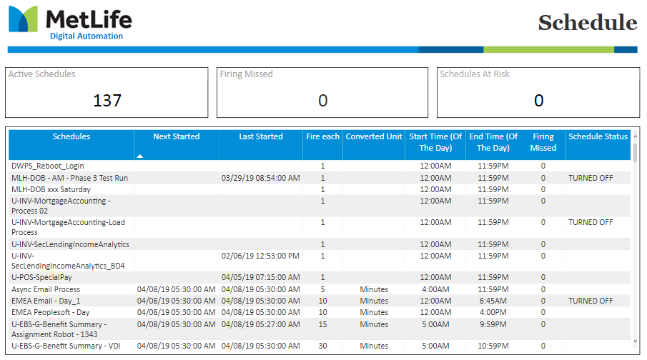

1. Stage Started

Captures if there is a potential risk of a stage getting stuck and not progressing forward in the process. Information of what bot it is running on along with stage information that may be helpful when troubleshooting.

* 1. Query

|  |
| --- |
| select Process  ,Resource  --,startdatetime  ,LastUpdated  ,LatestStage  ,Duration  ,cast(substring(Duration,1,2) AS int)*60+  cast(substring(Duration,4,2) AS int)+  cast(substring(Duration,7,2) AS int)/60.0 AS DurationInminutes  FROM  (  SELECT [processname] As Process  ,[runningresourcename] AS Resource  ,[startdatetime] AS startdatetime  ,[lastupdated] AS LastUpdated  ,[laststage] AS LatestStage  ,CASE WHEN lastupdated is null  THEN RIGHT('0' + CAST(DATEDIFF(SECOND, [startdatetime], GETDATE()) / 3600 AS VARCHAR),2) + ':' +  RIGHT('0' + CAST((DATEDIFF(SECOND,[startdatetime], GETDATE()) % 3600)/60 AS VARCHAR),2) + ':' +  RIGHT('0' + CAST(DATEDIFF(SECOND, [startdatetime], GETDATE()) % 60 AS VARCHAR),2)  ELSE  RIGHT('0' + CAST(DATEDIFF(SECOND, [lastupdated], GETDATE()) / 3600 AS VARCHAR),2) + ':' +  RIGHT('0' + CAST((DATEDIFF(SECOND,[lastupdated], GETDATE()) % 3600)/60 AS VARCHAR),2) + ':' +  RIGHT('0' + CAST(DATEDIFF(SECOND, [lastupdated], GETDATE()) % 60 AS VARCHAR),2)  END AS Duration  FROM [BPVSessionInfo] with (nolock)  WHERE statusid = '1'  )a    UNION ALL  SELECT '#*NA*#' as Process, 'NoData' as Resource, '1900-01-01 00:00:00.000' as LastUpdated, 'NoData' as 'LatestStage','00:00:00' AS Duration,0 AS DurationInminutes  ORDER BY DurationInminutes DESC |

* 1. Report Layout

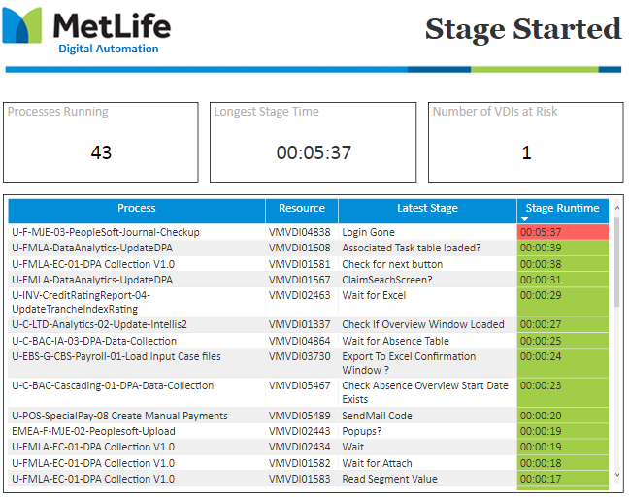

1. Terminations Watchers

Informs user when there are terminations so they can take actions. Allow user to see what process and bot the termination is occurring. Information can be useful to point to what time in a process it is failing.

* 1. Query

|  |
| --- |
| SELECT count(SessionNumber)SessionNumber, ProcessName, RunningResourceName  FROM  (  Select TERMINATED_SESSIONS.sessionnumber As SessionNumber, TERMINATED_SESSIONS.processname As ProcessName, TERMINATED_SESSIONS.runningresourcename as RunningResourceName, convert(varchar(30),TERMINATED_SESSIONS.startdatetime,121) as StartDatetime,  convert(varchar(30),TERMINATED_SESSIONS.enddatetime,121) as EndDatetime,  ST.[description] as Description,  (SELECT '[STAGE: ' + SL.stagename + ' | RESULT: ' + CONVERT(VARCHAR(255), SL.result) + ']; '  FROM [dbo].[BPASessionLog_NonUnicode] SL with (nolock)  WHERE SL.sessionnumber = TERMINATED_SESSIONS.sessionnumber  AND SL.result LIKE '%ERROR%'  FOR XML PATH(''))AS Result ,lastupdated  From  (  SELECT [sessionnumber]  ,[processname]  ,[runningresourcename]  ,[startdatetime]  ,[starttimezoneoffset]  ,[enddatetime]  ,[endtimezoneoffset]  ,[lastupdated]  ,[statusid]  FROM [dbo].[BPVSessionInfo] with (nolock)  Where  DATEDIFF(HOUR, [lastupdated], GETDATE()) <= 4  AND  (statusid = 2 OR statusid = 3)  And lastupdated In (Select Max(lastupdated) From [dbo].[BPVSessionInfo] WITH (NOLOCK) Group by sessionid)  ) AS TERMINATED_SESSIONS  JOIN BPAStatus ST WITH (NOLOCK) ON TERMINATED_SESSIONS.statusid = ST.statusid  UNION ALL  SELECT 0 as SessionNumber, '#*NA*#' as ProcessName, '#*NA*#' as RunningResourceName, '1900-01-01 00:00:00.000' as StartDatetime, '1900-01-01 00:00:00.000' as EndDatetime  ,'NoData' as Description, 'NoData' as Result, '1900-01-01 00:00:00.000' as lastupdated  )tsessions  GROUP BY ProcessName,RunningResourceName  ORDER BY SessionNumber DESC |

* 1. Report Layout

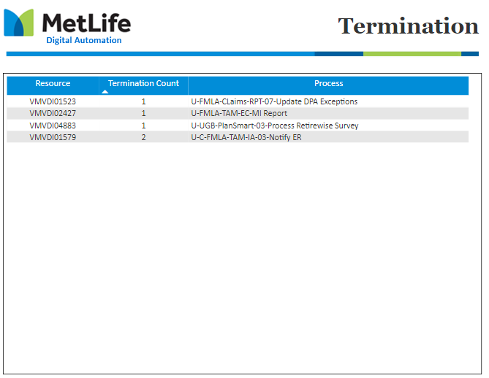



**Deployment document for Blue Prism Realtime Reports**

Contents

Revision History 3

Prerequisites 4

Pre-requisite installation 4

Gateway Server setup and Configuration 6

Report Deployment 16

Powershell scripts setup 20

Create windows Scheduler Job to trigger the Powershell script 21

Monitor the Powershell script 24

View the report and Dashboard 26

|  |  |
| --- | --- |
| **Document:** | Deployment document for Blue prism Real time refresh reports |
| **Document Name:** | Deployment document for Blueprism Realtime Reports V1.0.docx |
| **Author:** | Rajesh R Nair |
| **Last Updated:** | 09-Apr-2019 |
| **Version:** | V1.0 |

## Revision History

|  |  |  |  |  |
| --- | --- | --- | --- | --- |
| Date | Version # | Summary of Changes | Author | Comments |
| 01-Apr-2019 | 0.1 | Initial version | Rajesh R Nair |  |
| 09-Apr-2019 | 1.0 | Updated | Rajesh R Nair |  |
|  |  |  |  |  |
|  |  |  |  |  |

## Prerequisites

The below are the pre-requisites software that needs to be installed to execute the Powershell script. This Powershell script will push the latest data into the stream dataset for every 10sec. This is one time process and to be performed for each environment, if the software are not installed.

1. Install .Net Framework 4.72
2. Install Windows Management Instrumentation 5.1 ()
3. Install MicrosoftPowerBIMgmt

## Pre-requisite installation

Install .Net Framework 4.7.2 runtime from the below link

<https://dotnet.microsoft.com/download/dotnet-framework/net472>

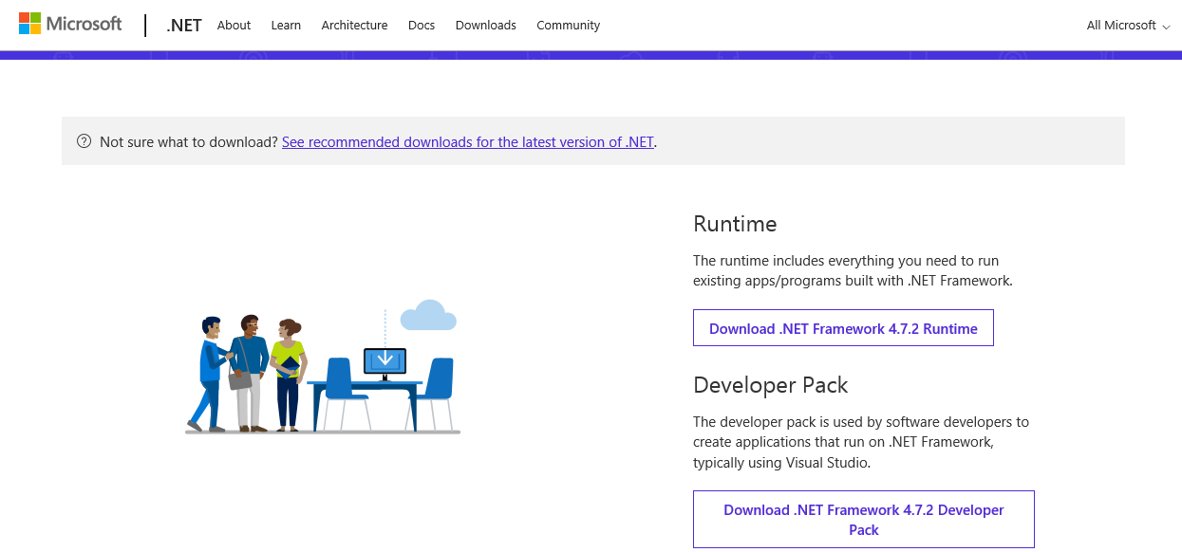

Download and install Windows Management Framework from the below link

<https://www.microsoft.com/en-us/download/details.aspx?id=54616>

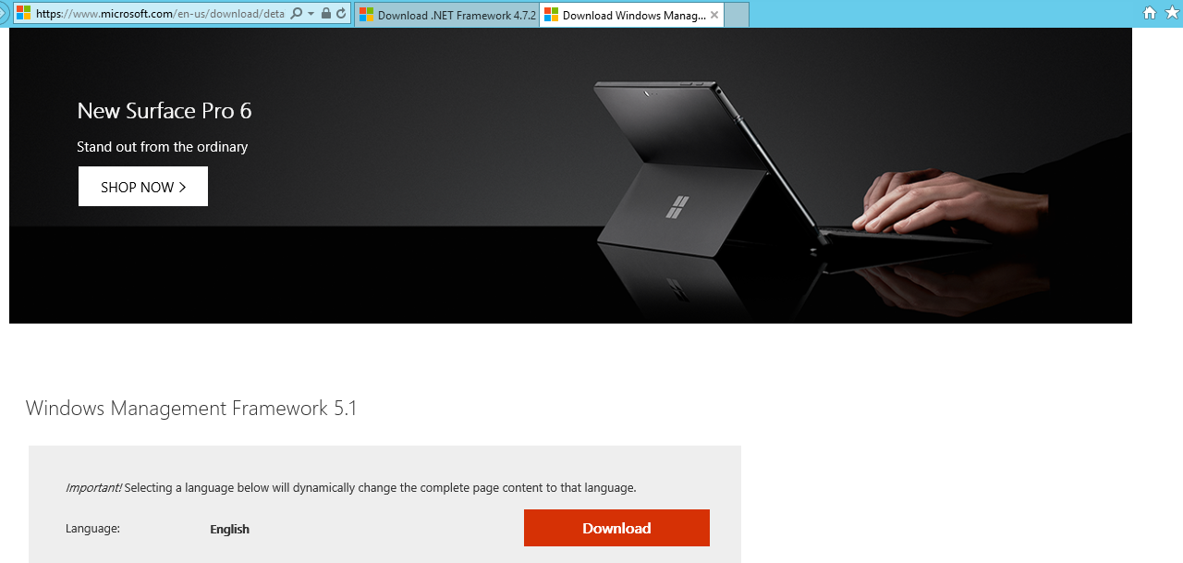

Open Powershell with run as Administrator

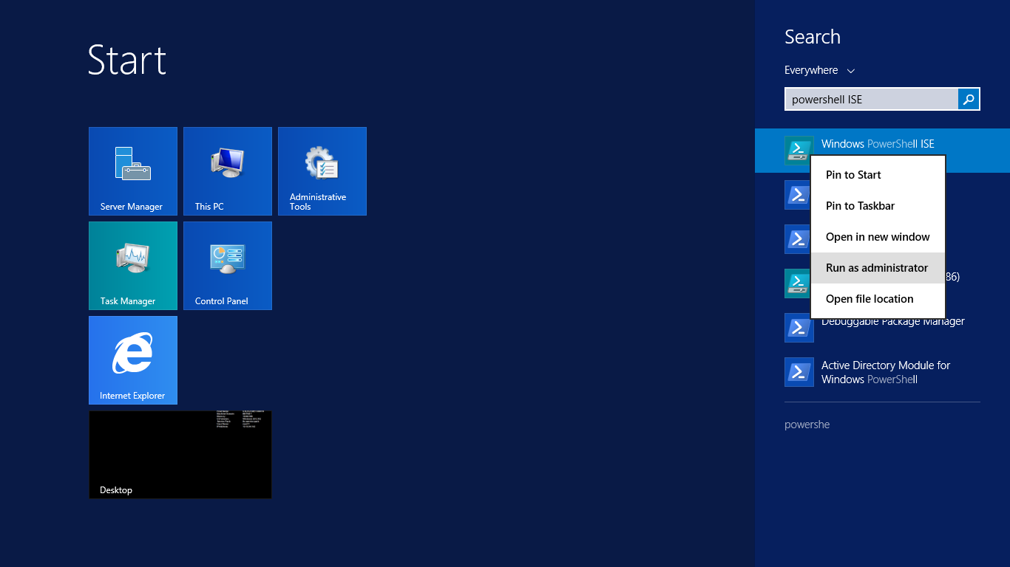

Install PowerBI Management Module with the below command in Powershell ISE window

Install-Module -Name MicrosoftPowerBIMgmt

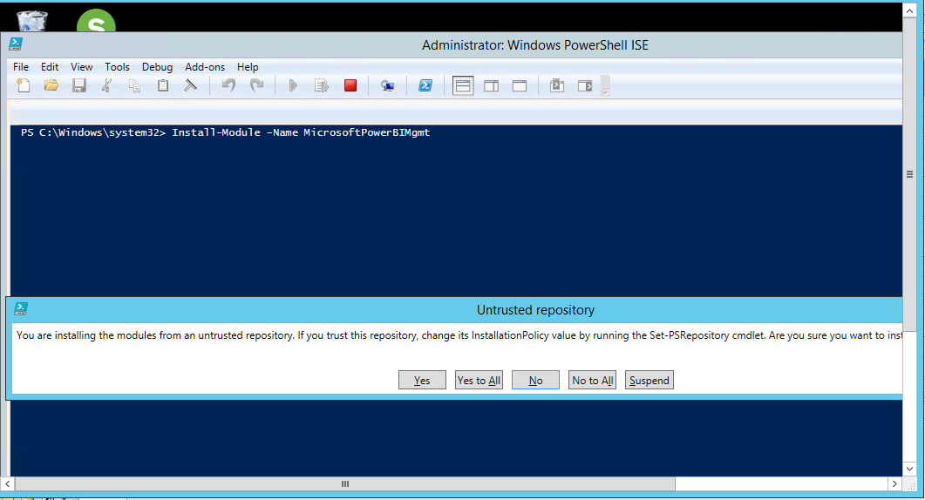

Click “Yes to All” and install the module.

## Gateway Server setup and Configuration

Power BI Gateway serves as a bridge for data transfer between on premise data source and Power BI reports, hosted in Cloud.

Gateway services works with following flow

1. Power BI cloud service generates data source query, analyzes and pushes the request to Azure Service Bus queue.
2. On premise Power BI gateway polls Azure service bus for pending requests. Gateway service will connect to Azure service Bus via TCP to Azure IP addresses. IP addresses have to whitelisted in On premise firewall.
3. The gateway gets the query, decrypts the credentials and connects to the data source(s) with those credentials.
4. The gateway sends the query to the data source for execution.

The results are sent from the data source, back to the gateway, and then onto the cloud service. The service then uses the results

Data Management Gateway

Source



1. **Server Requirements for Gateway install**

* **Minimum Requirements:**
  + .NET 4.5 Framework
  + 64-bit version of Windows 7 / Windows Server 2008 R2 (or later)
* **Recommended:**
  + 8 Core CPU
  + 8 GB Memory
  + 64-bit version of Windows 2012 R2 (or later)

1. **Considerations**

* Cannot be installed on domain controller
* Recommended to Install on the data source server.
* Only one Gateway service can be installed on a on premise computer.
* On premise server , with Gateway set up, needs to be always ON and available.
* On premise server, with Gateway set up, needs to be directly linked to network instead of wireless.
* Recommended to install gateway at same server as that of data source.
* Configure Power BI Gateway service to use Power BI administrator account instead of default service account - NTSERVICE\PBIEgwService

1. **Gateway Installation & Configuration Steps**

Power BI Gateway set up can downloaded from <https://powerbi.microsoft.com/es-us/gateway/> . Click on GatewayInstall.exe

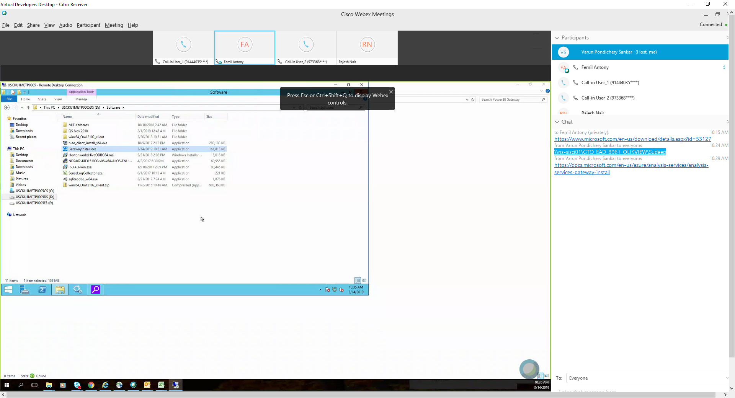

1. Click next to proceed

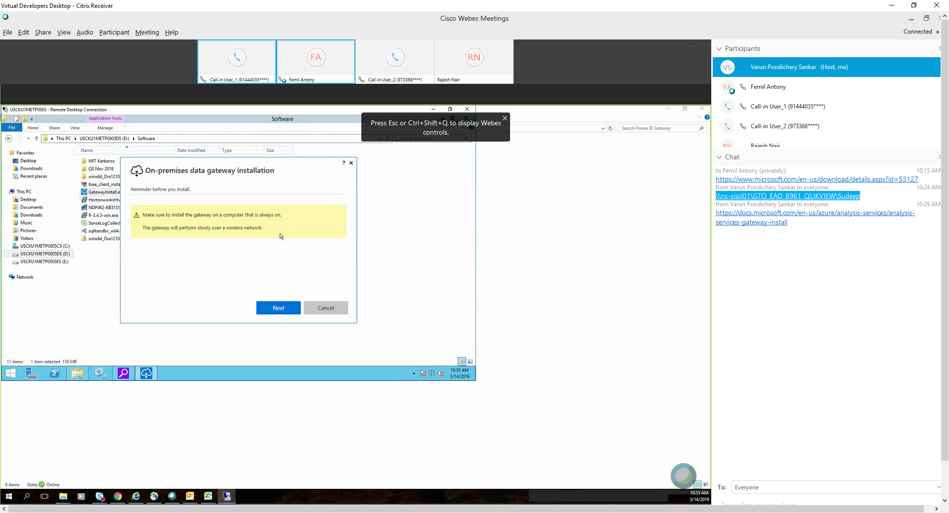

1. Select install folder location, review and accept agreement. Click next.

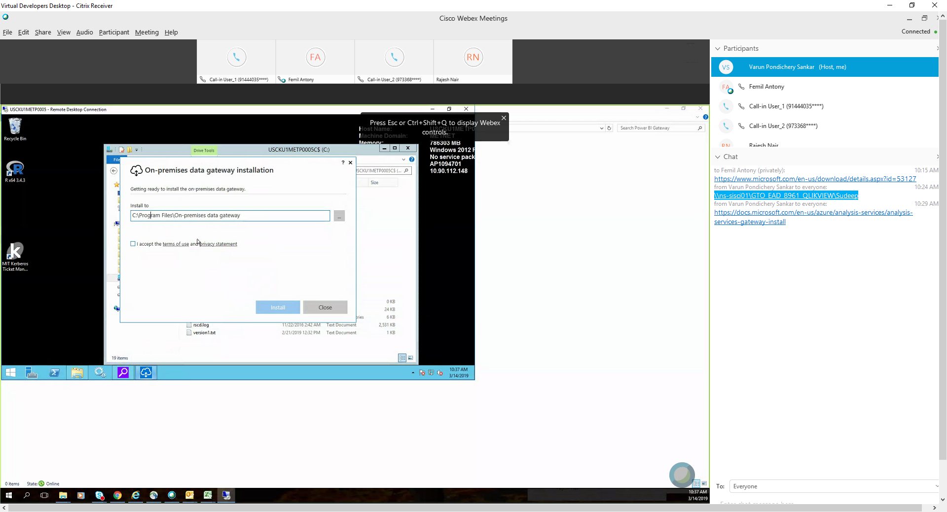

1. Click Yes in User access control dialog for elevated permission to run install.

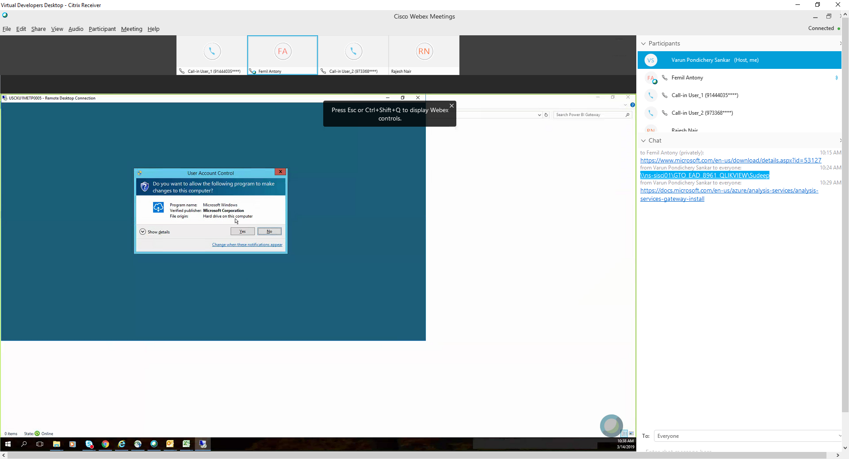

1. Installation progress is shown subsequently

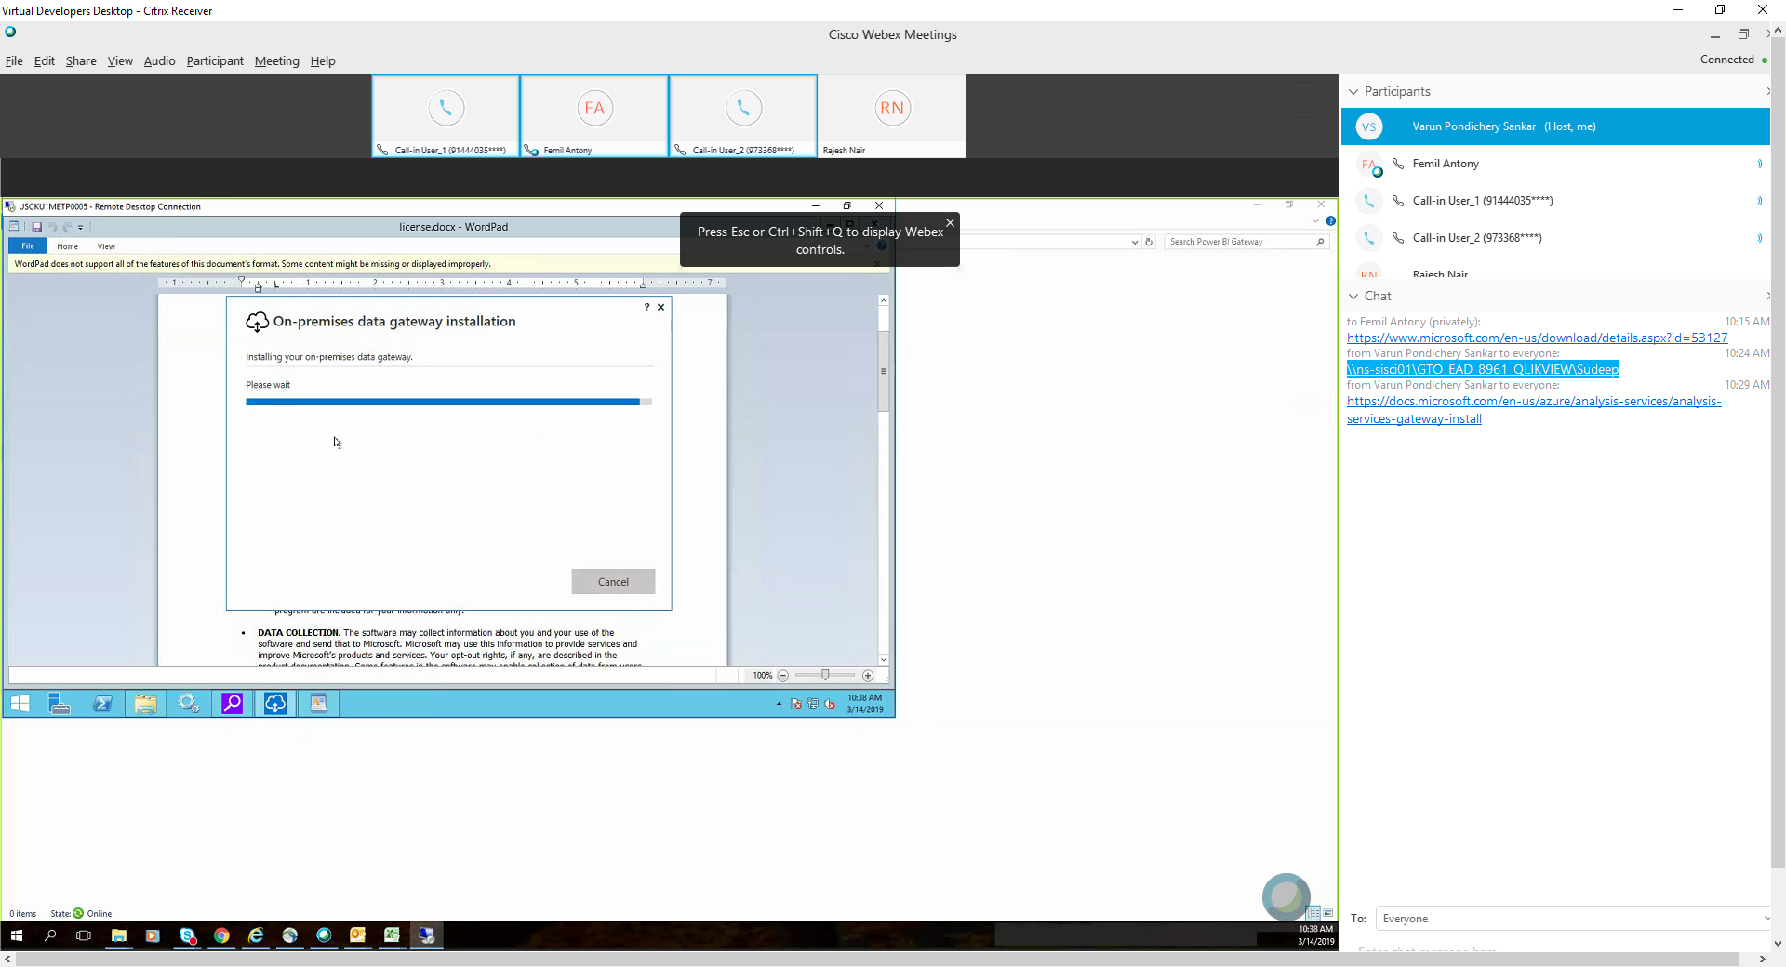

1. Enter a email address for gateway configuration and providing cloud access to gateway. Preferable to use functional email address.

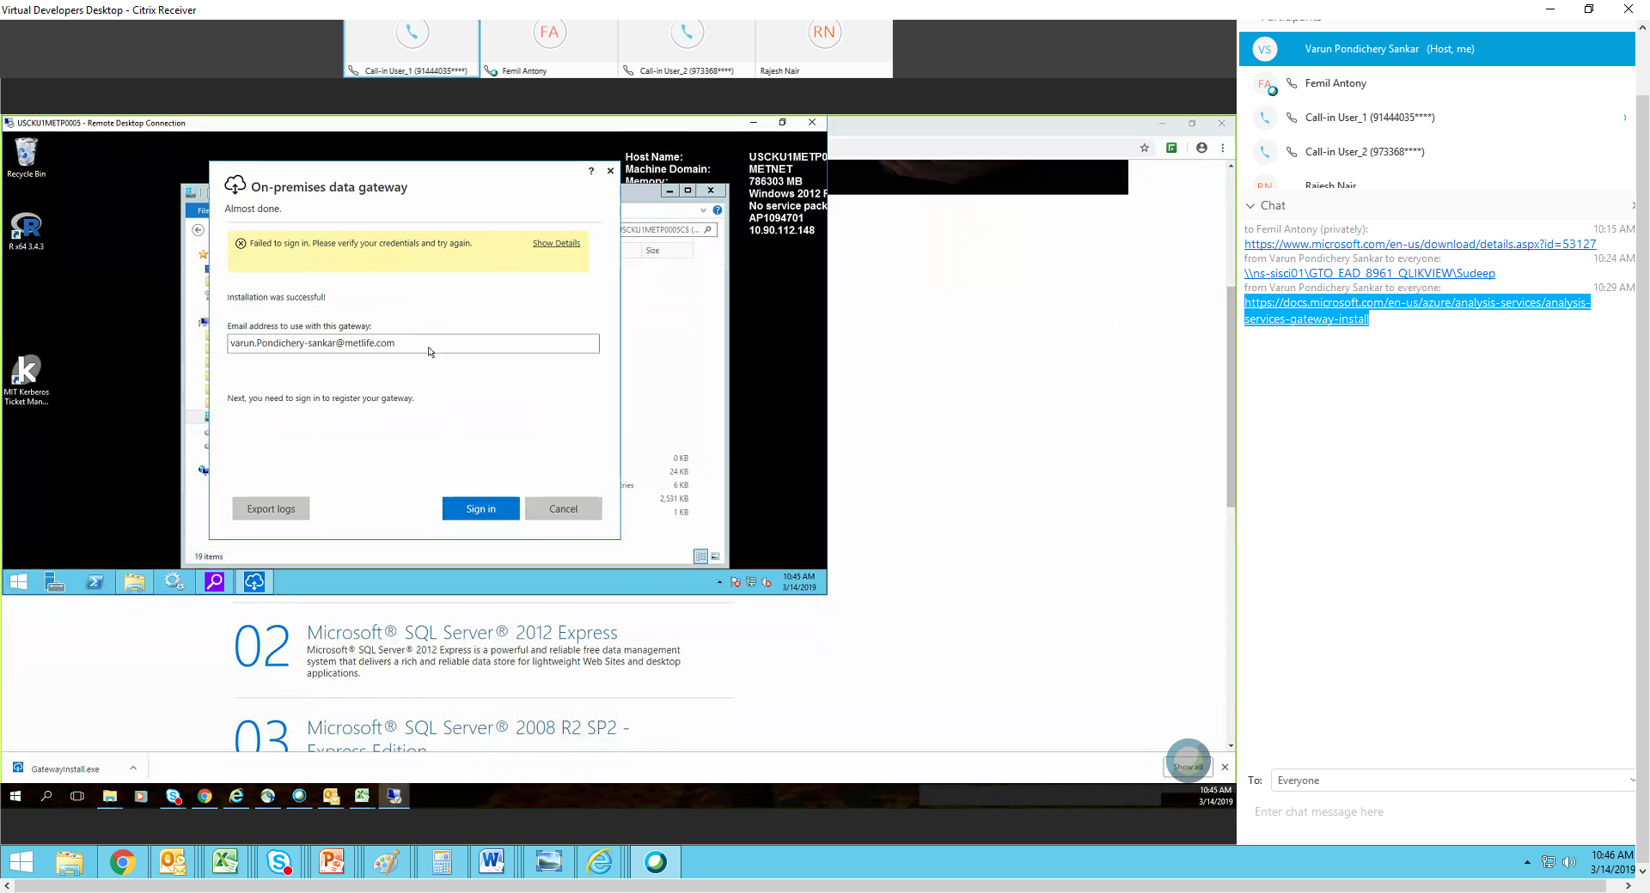

1. Authenticate with the METNET functional ID

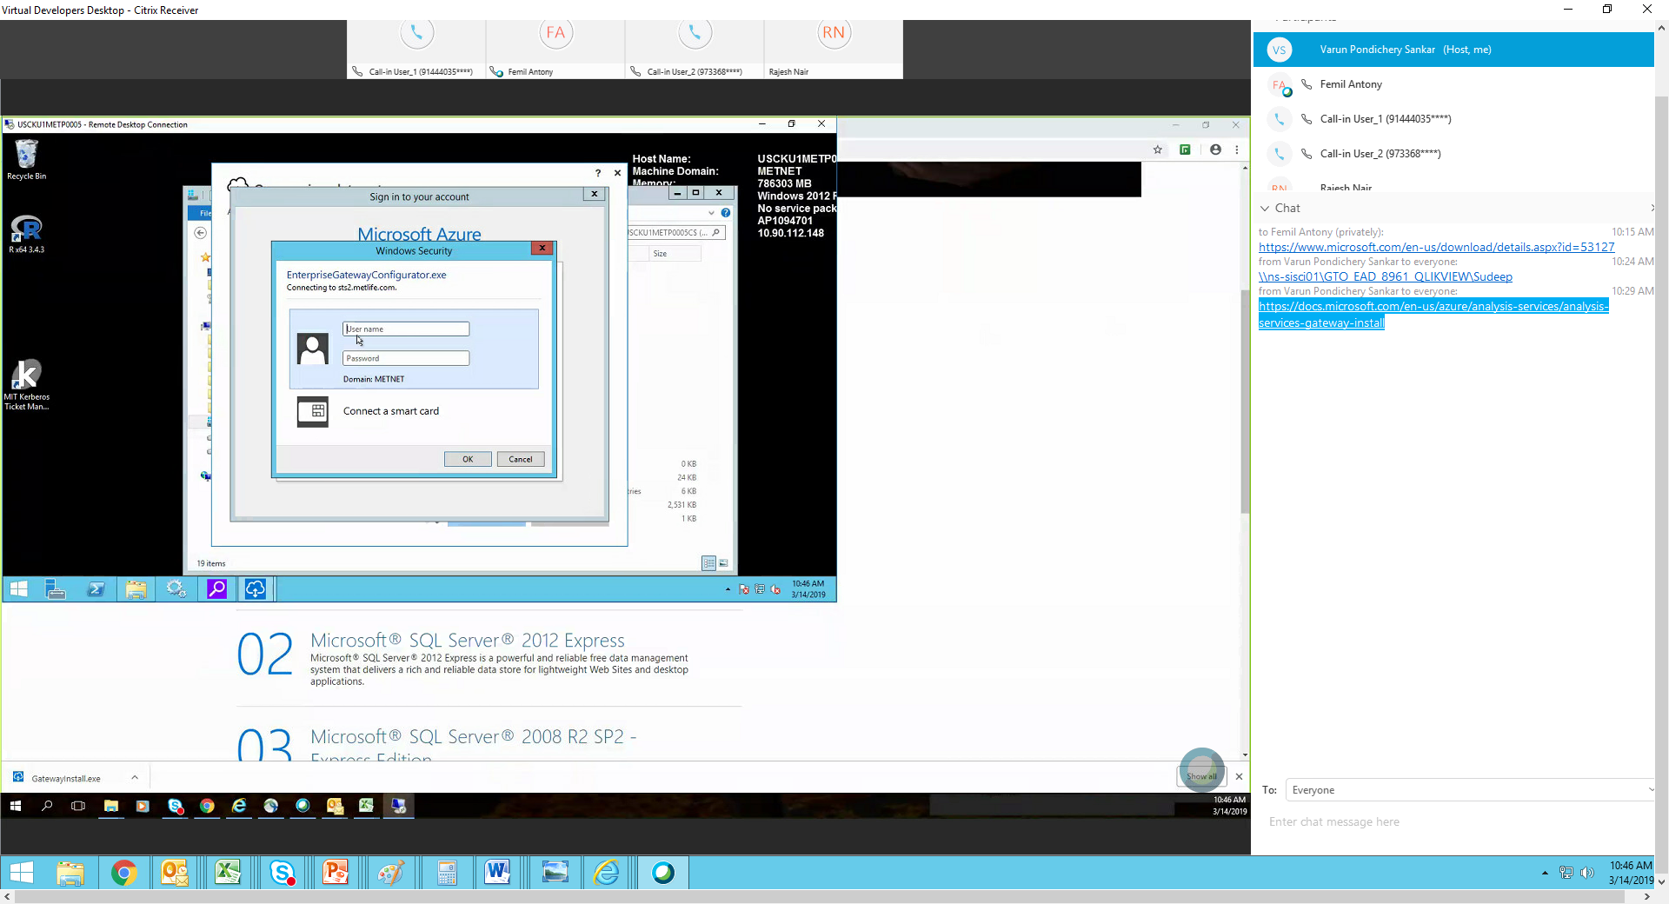

1. Register as new gateway service and click next

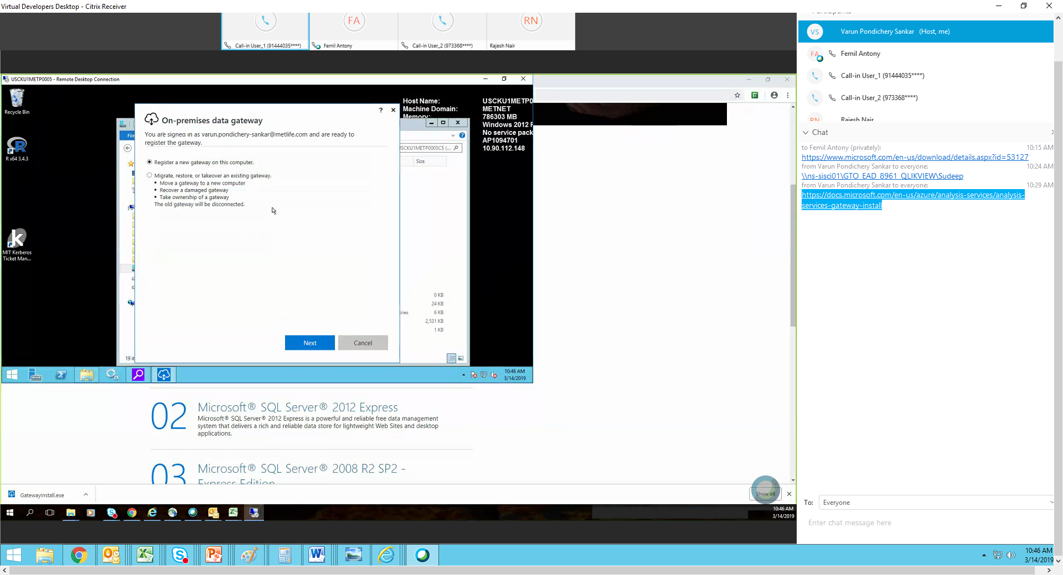

1. Enter gateway service name and recovery key for gateway restoration

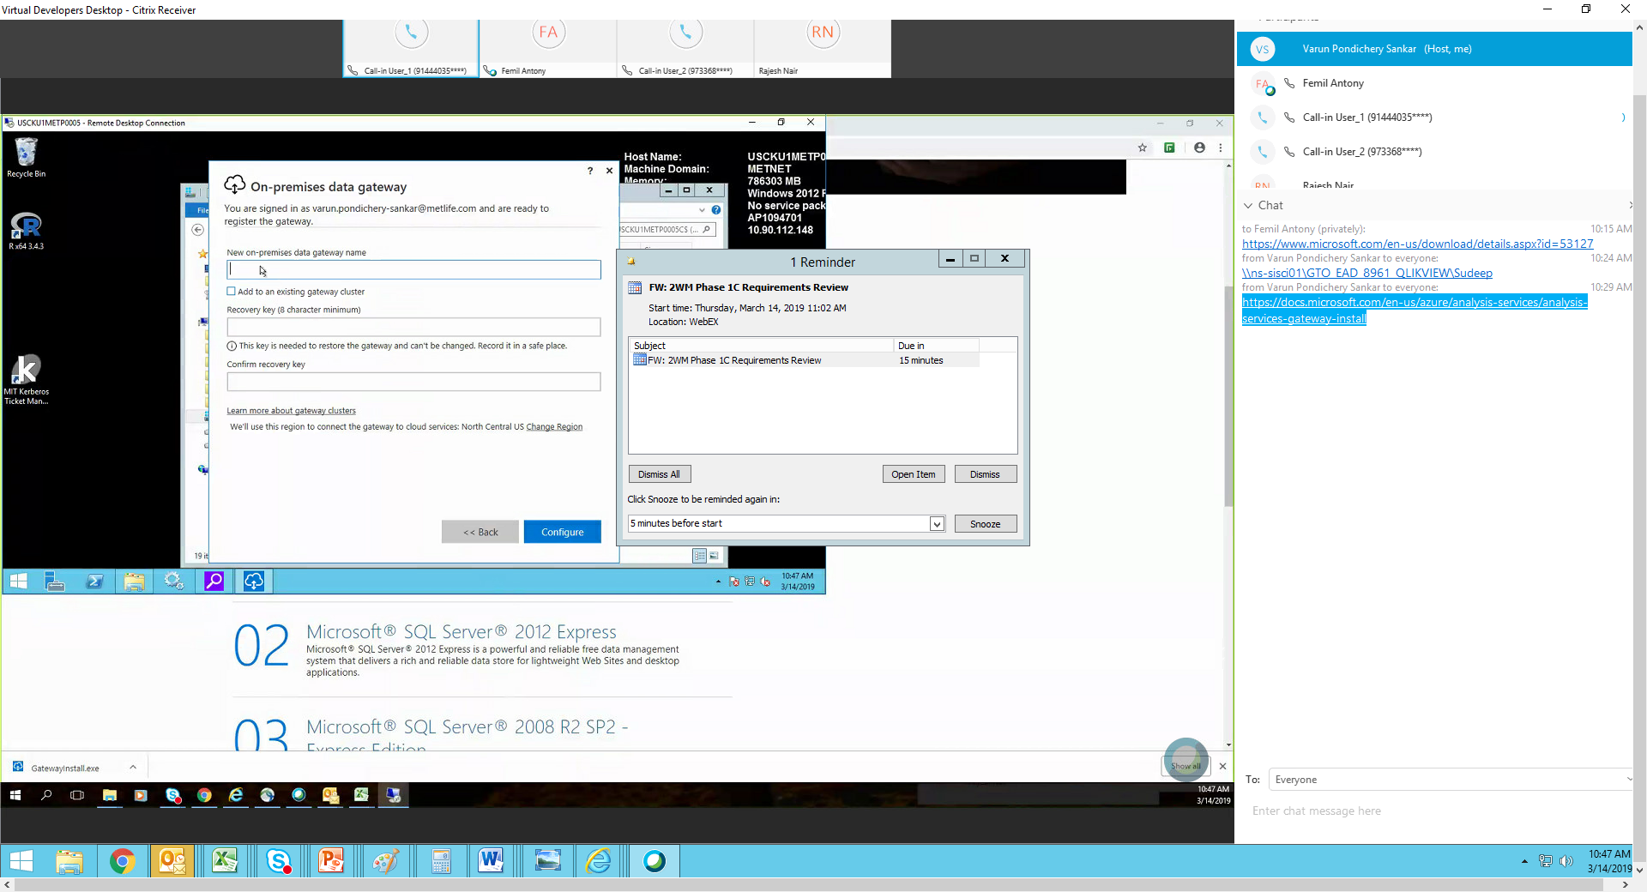

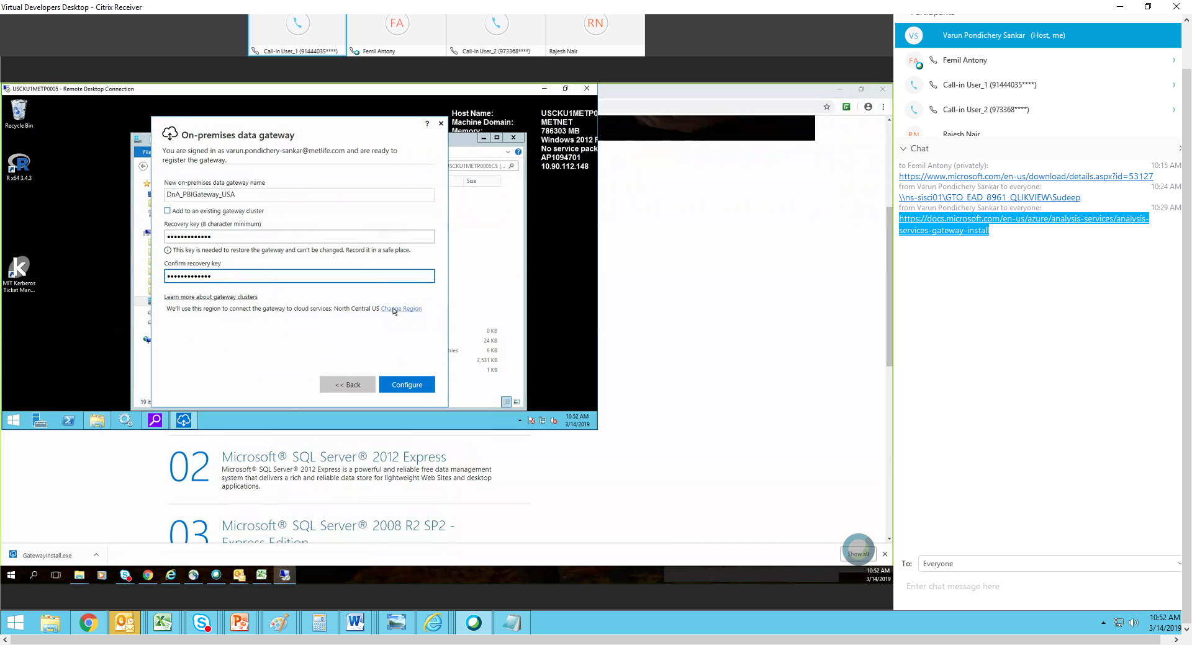

8. Gateway install and configuration is completed.

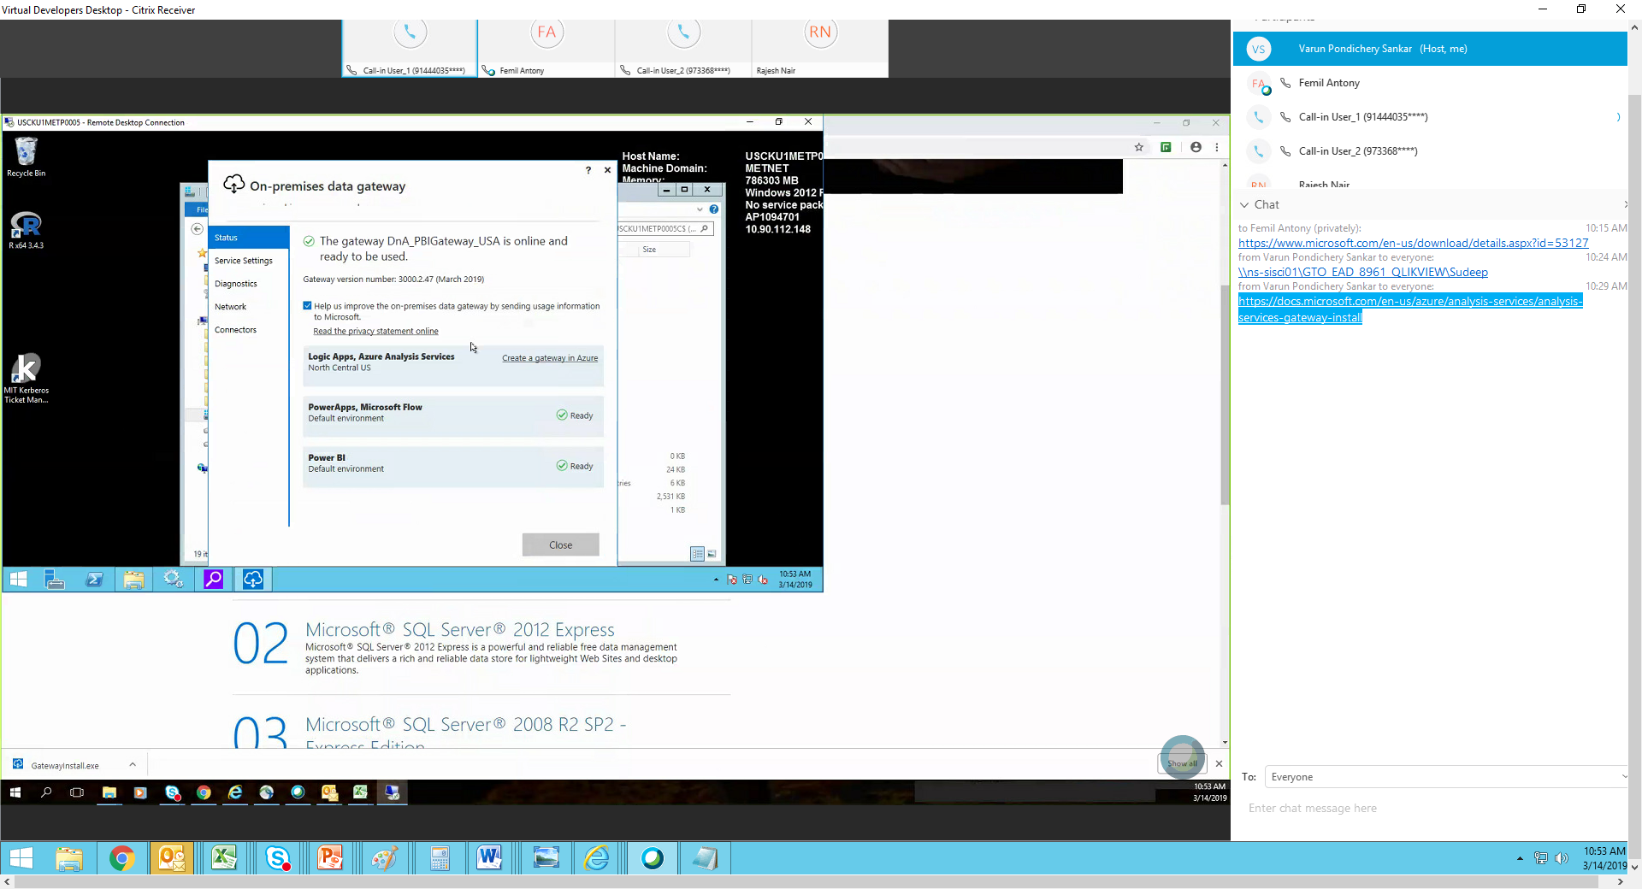

1. Enable logging to audit and track on issues.

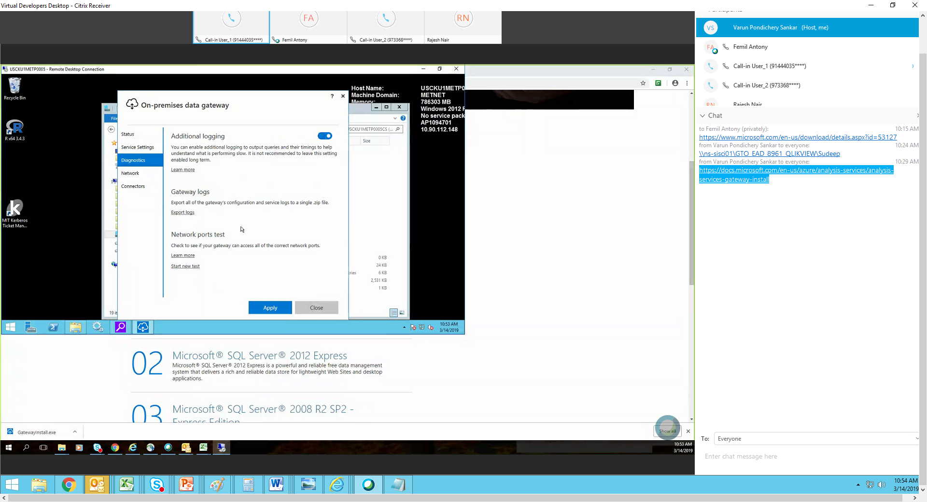

1. Review and verify log folder

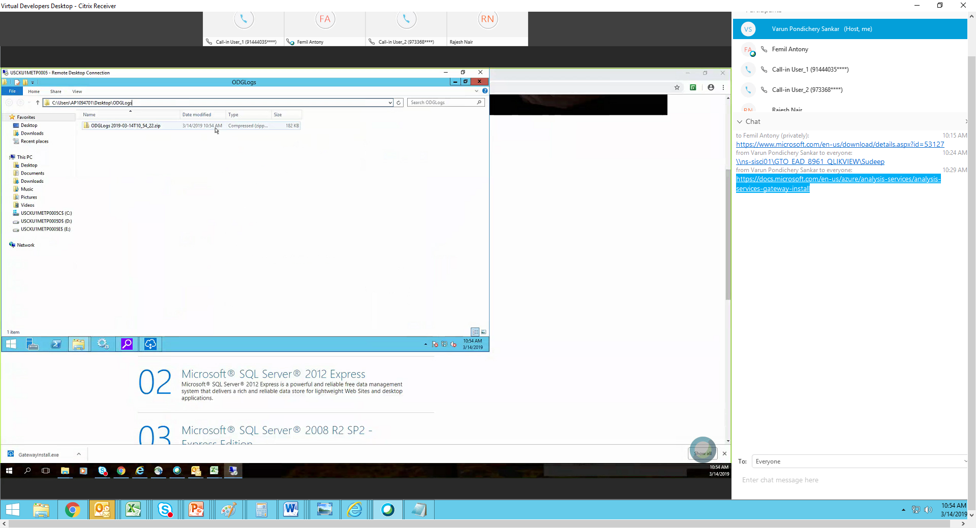

1. Select re start later

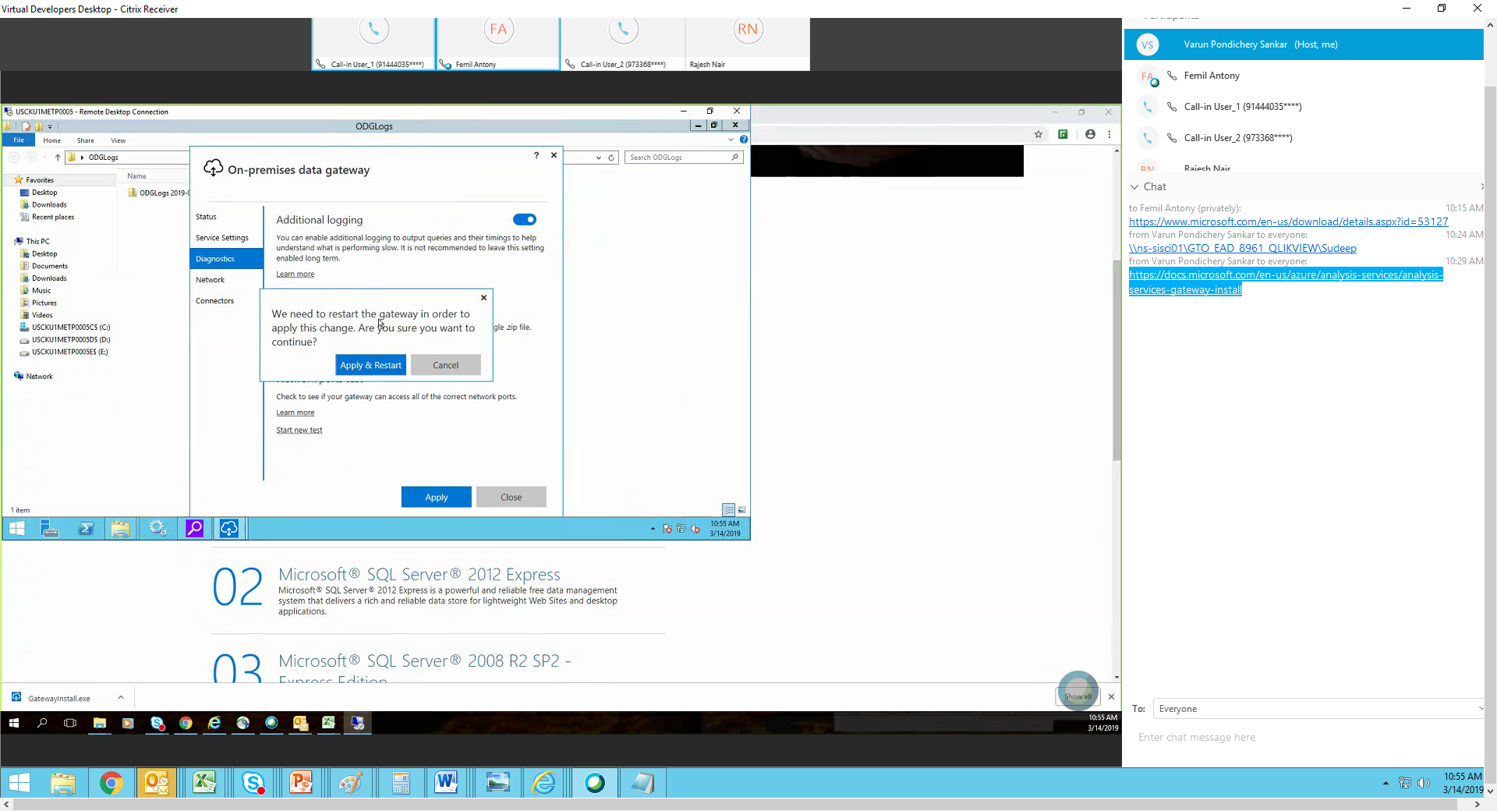

1. Review location of customer data connectos

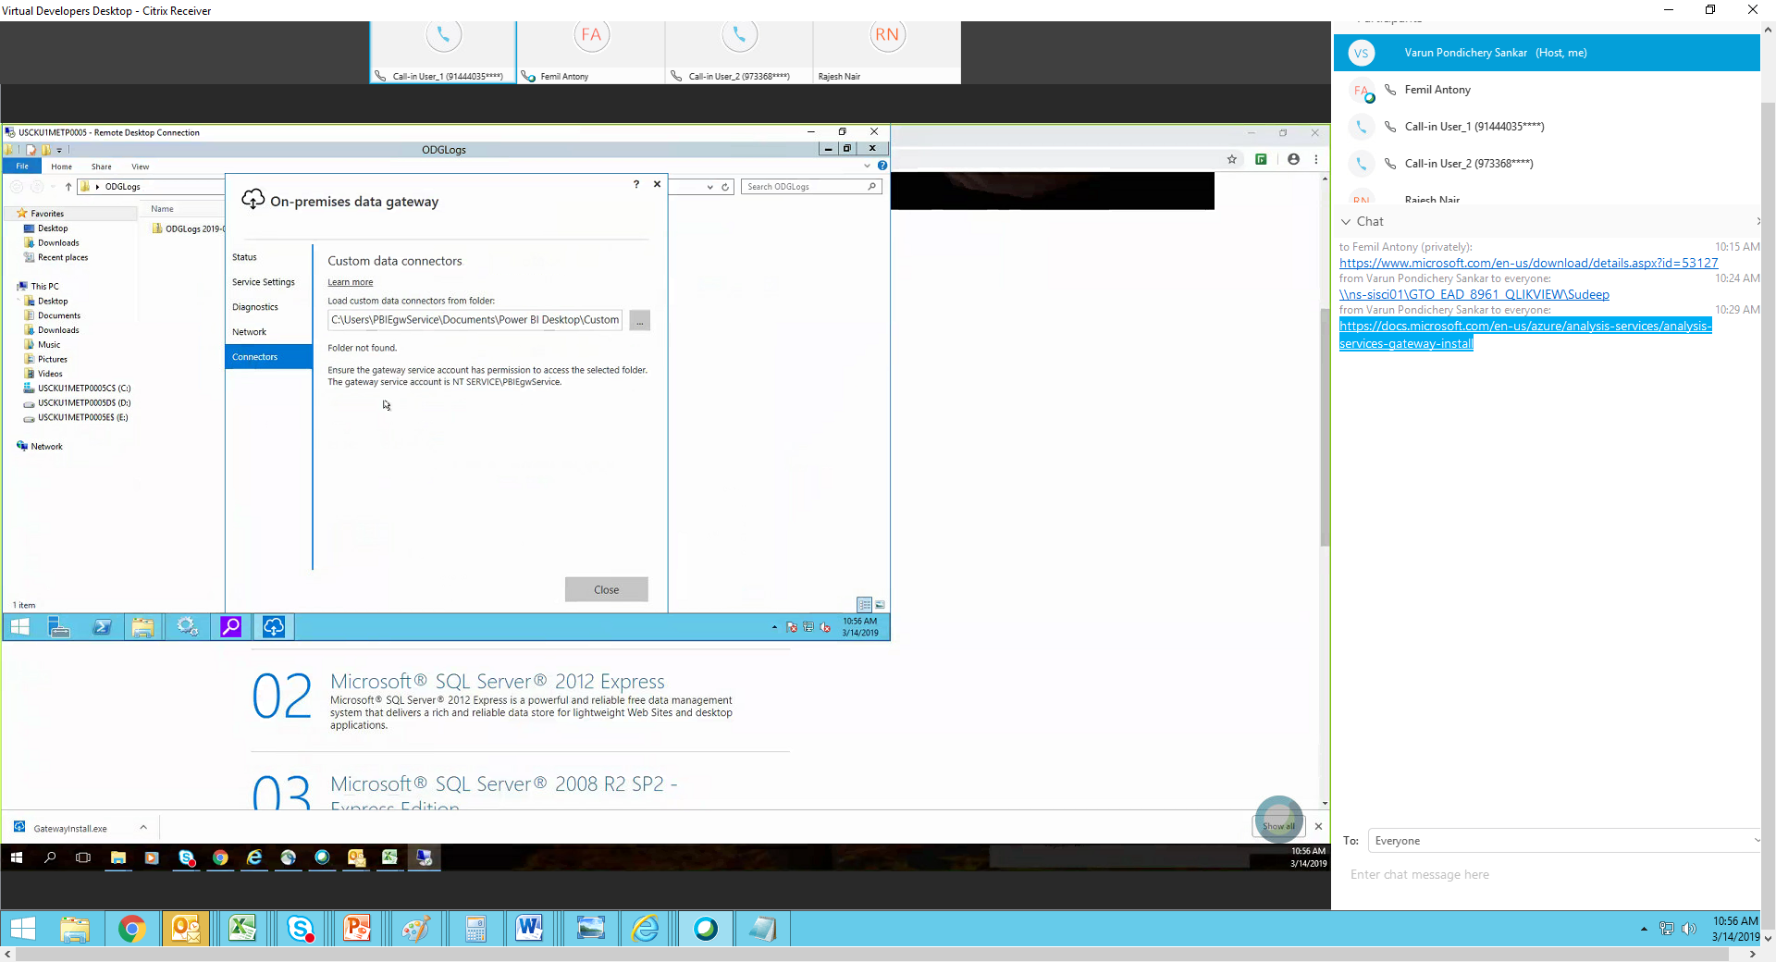

## Report Deployment

The below steps to be followed to perform the report deployment in the environment. These steps to be repeated for each report.

1. Create Stream Dataset in Production workspace GTO_BluePrism_PBI_US_PROD. The column name and the datatype should exactly match with the data retrieved from the back-end. Ensure to enable “Historic Data analysis” on.

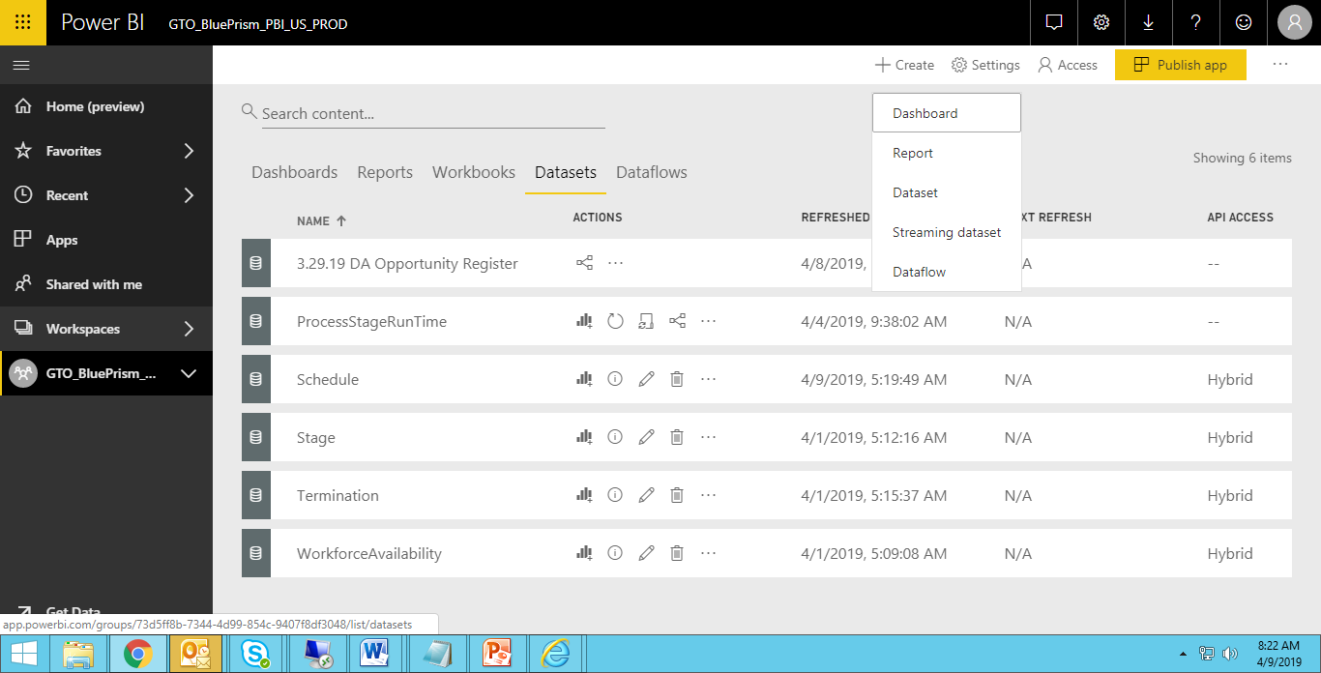

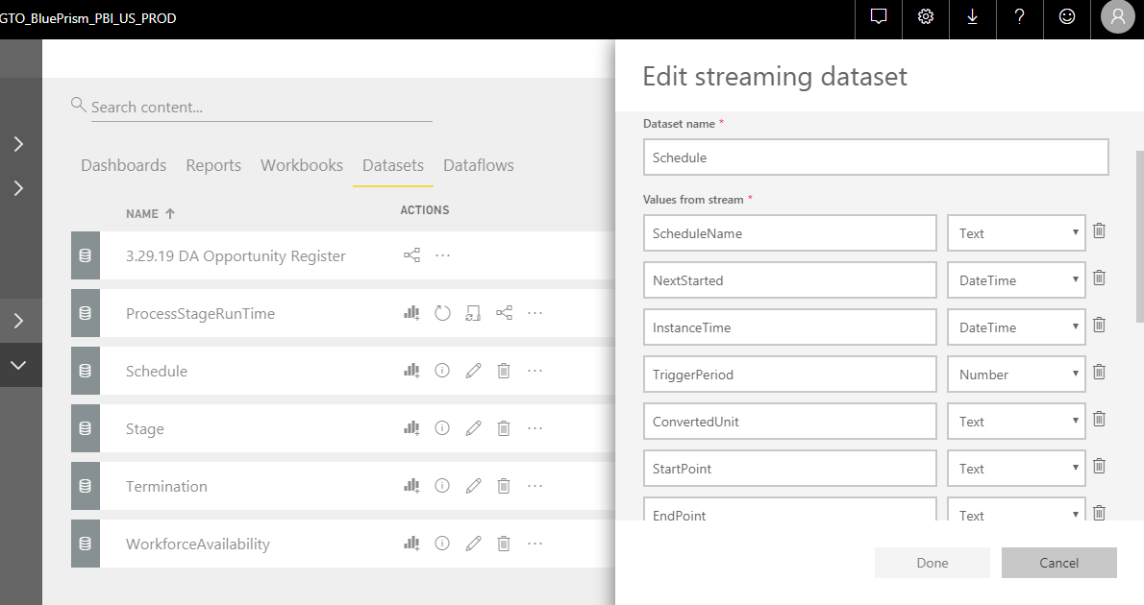

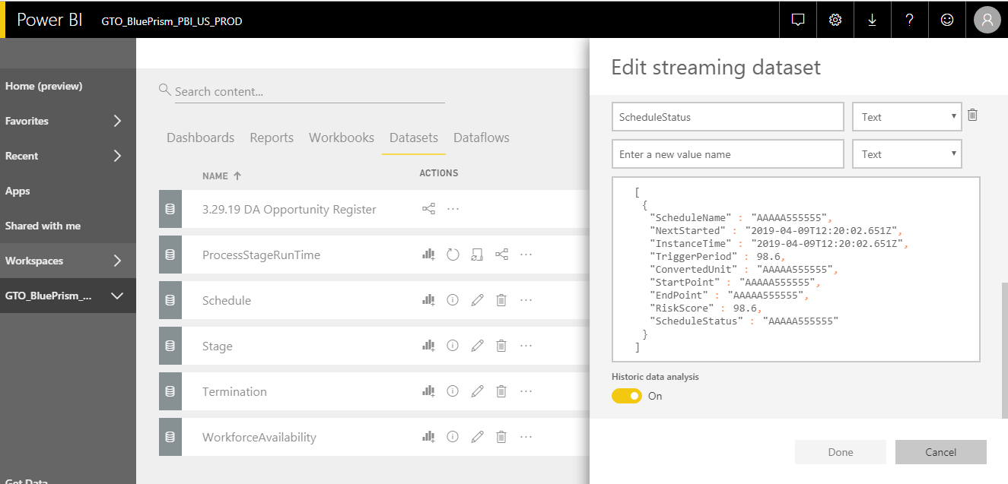

1. Point the report to the stream dataset in Production workspace.

Open the report in the latest version of the Power BI desk top and point the data source to the production dataset which created just now.

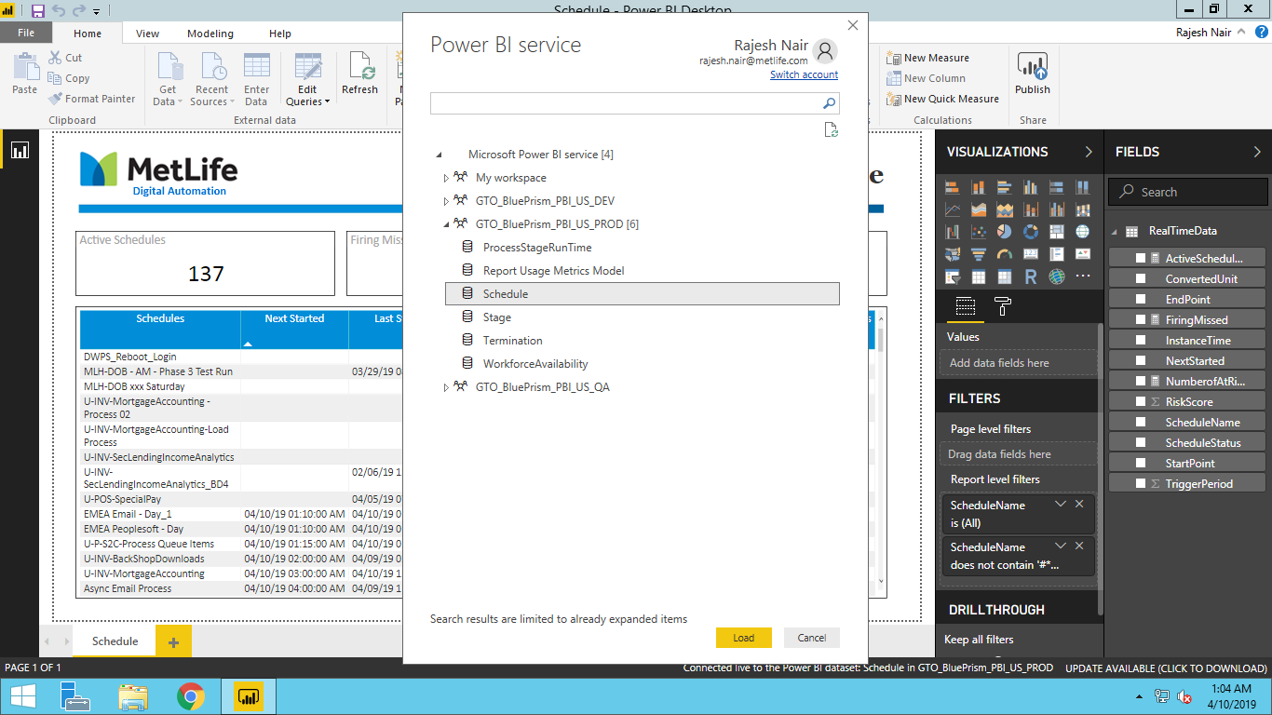

1. Deploy the report into the Prod

Click on the “Get Data” at the Left bottom of the screen and click on the “Get” button under “Files”

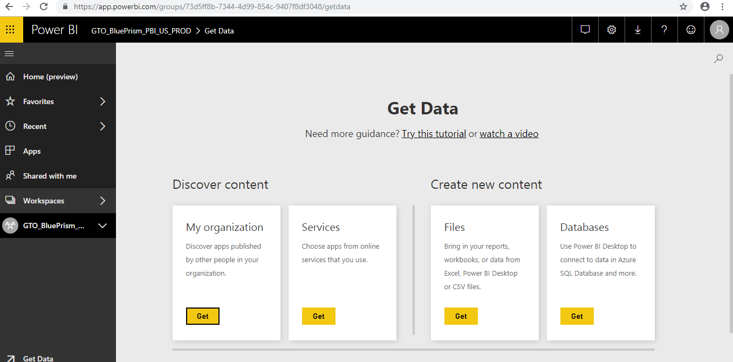

Click on Local File

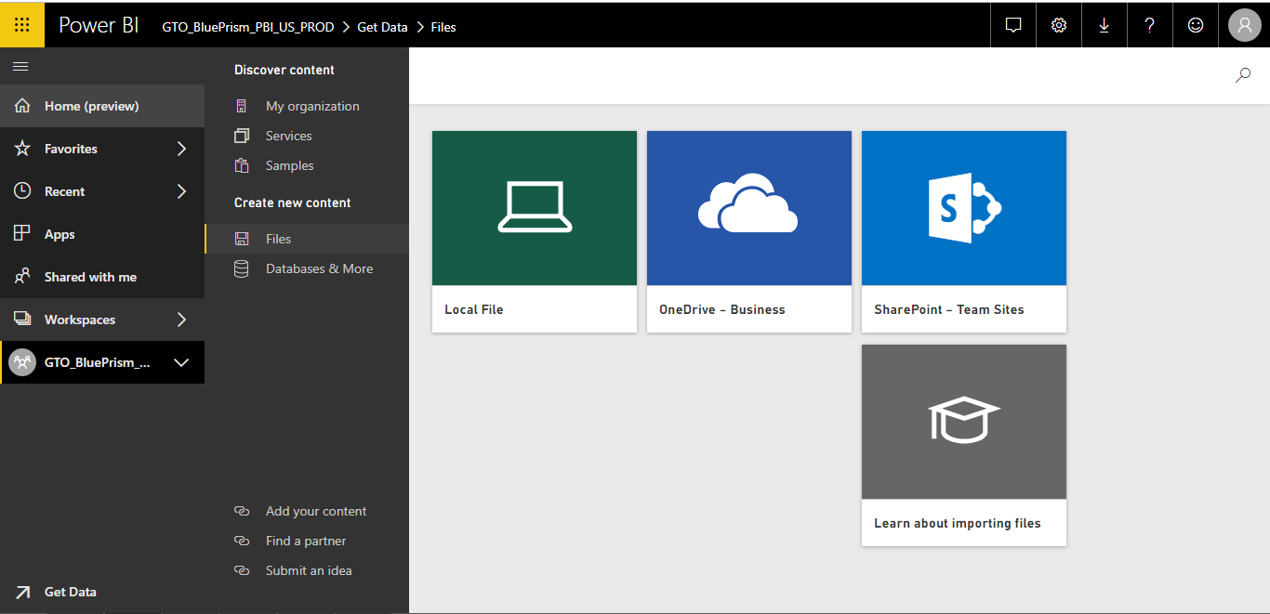

Browse and open the .pbix file.

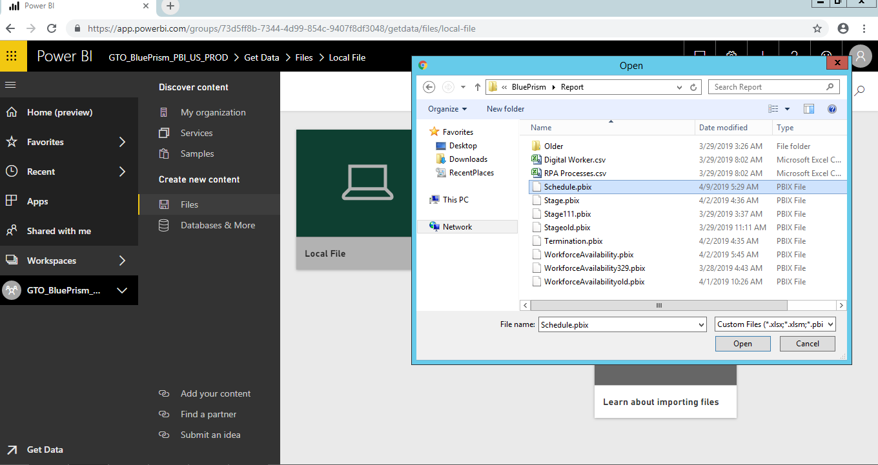

Confirm to replace the file, if it exists

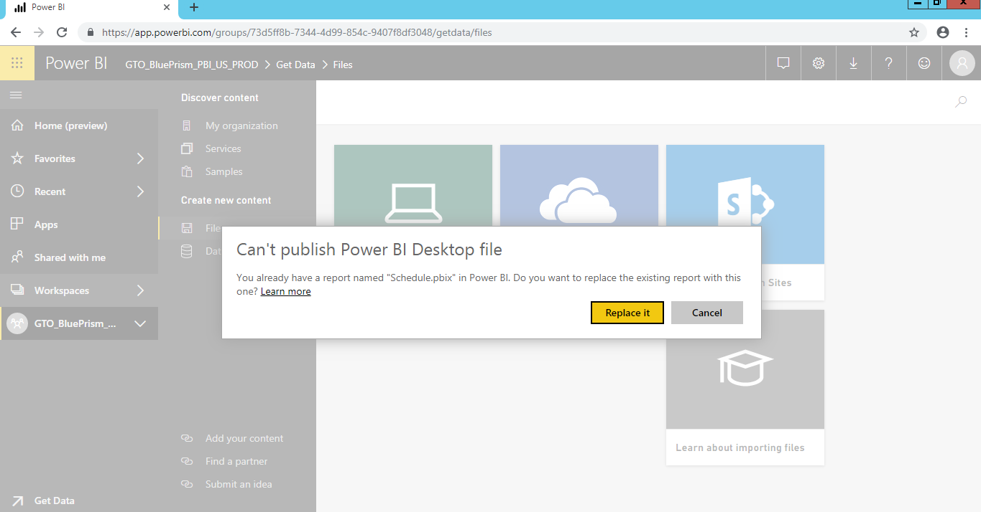

1. Create Dashboard for the report

Edit the report in Cloud Workspace and click on each visual in the report and pin it to the Dashboard

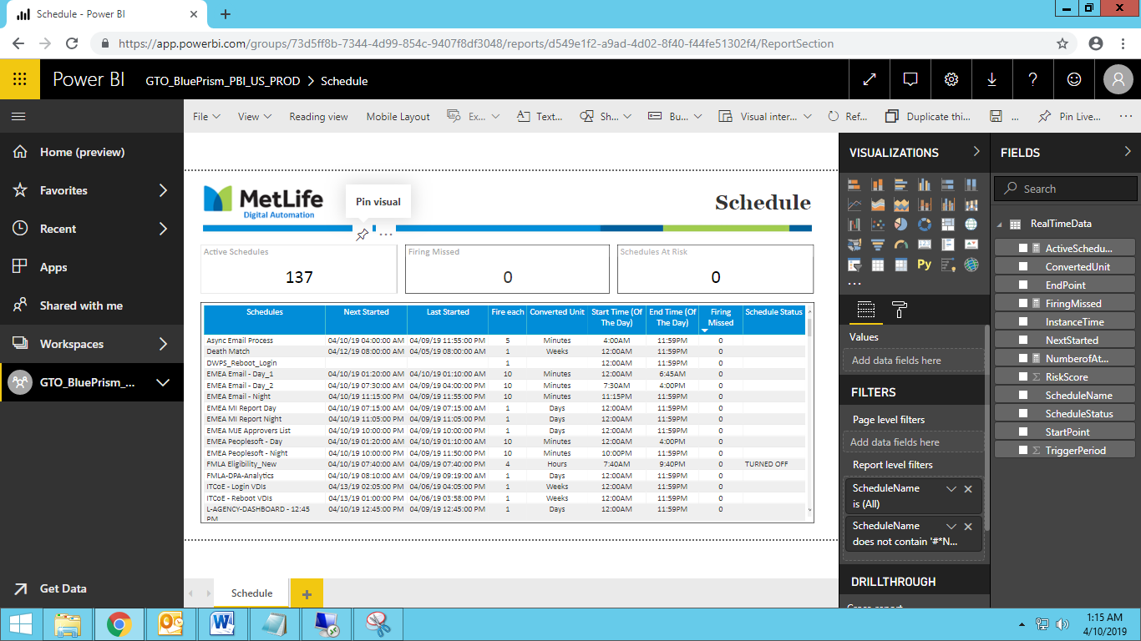

## Powershell scripts setup

1. Copy the below files into D:\Blueprism folder in the server
2. BluePrismRealTimeRefresh.ps1
3. Control.ini
4. RealTimeRefresh.bat
5. Copy the push URL for the dataset and replace the corresponding endpoint URL and Dataset Key in the Powershell script. This step to be repeated for each report.

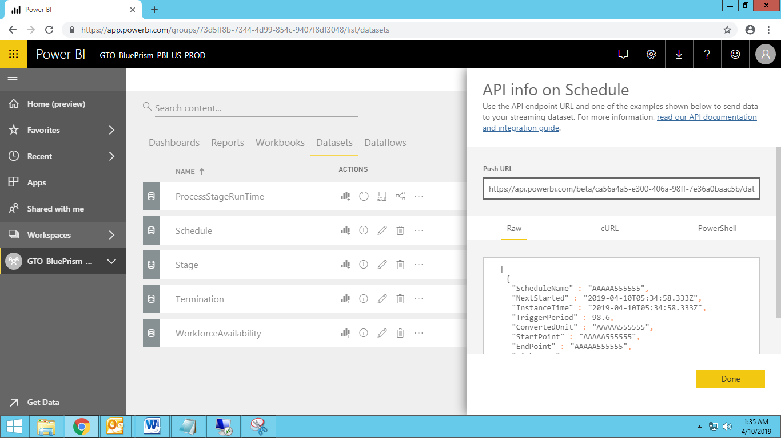

Sample endpoint URL and Dataset Key usage for one report is given below

$endpointu2 = "https://api.powerbi.com/beta/ca56a4a5-e300-406a-98ff-7e36a0baac5b/datasets/a615fa98-f1a0-4e60-9177-08bfec9a873e/rows?key=%2BsWOUVqYpclpLV0i4tFnudJxhz5PX%2B6Lu5DCrNRGonpMG2SDYeNdmrJdPO9uP6jWjN4BUM5SXbqThs1CbxpiRQ%3D%3D"

Remove-PowerBIRow -Datasetid a615fa98-f1a0-4e60-9177-08bfec9a873e -TableName RealTimeData

1. Generate AES Key and encrypt the Power BI password for the user ID stores in D:\BluePrism folder

#Create aes key

$Key = New-Object Byte[] 32

[Security.Cryptography.RNGCryptoServiceProvider]::Create().GetBytes($Key)

$Key | out-file d:\Blueprism\Secure\aes.key

#create password

(get-credential).Password | ConvertFrom-SecureString -key (get-content D:\BluePrism\Secure\aes.key) | set-content "D:\BluePrism\Secure\password.txt"

## Create windows Scheduler Job to trigger the Powershell script

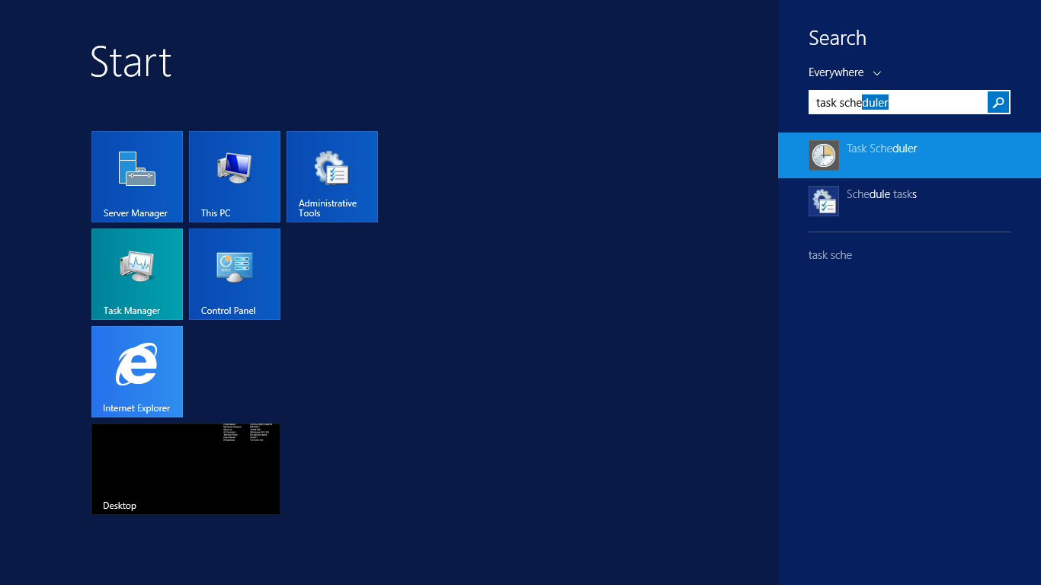

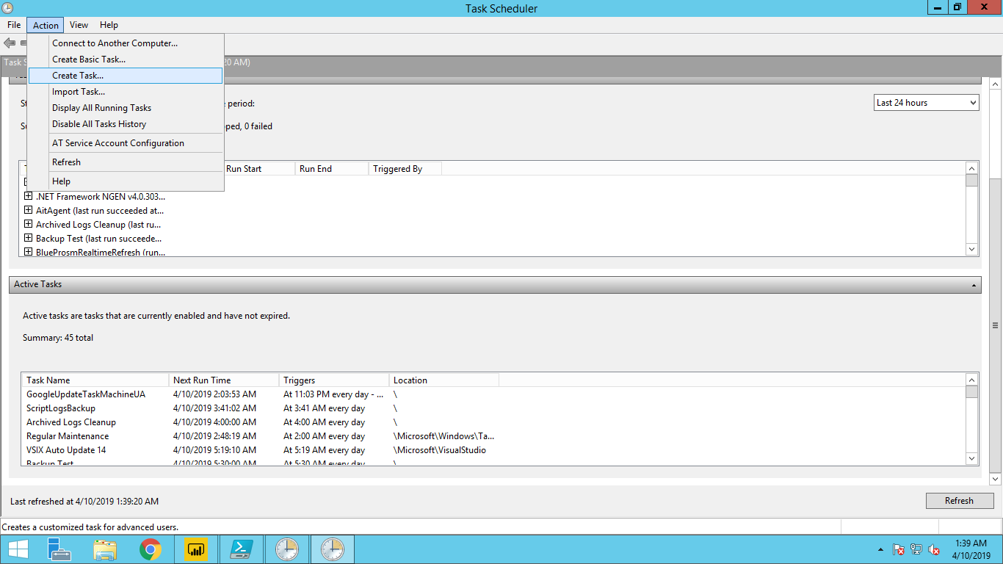

Create “BluePrism Realtime Refresh” task and configure it to execute batch file. Ensure to execute the job under MetNet\AP1088815 account.

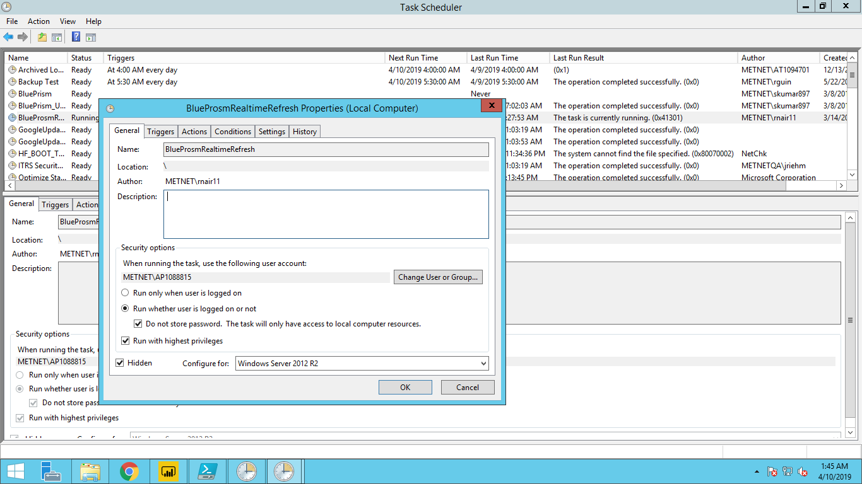

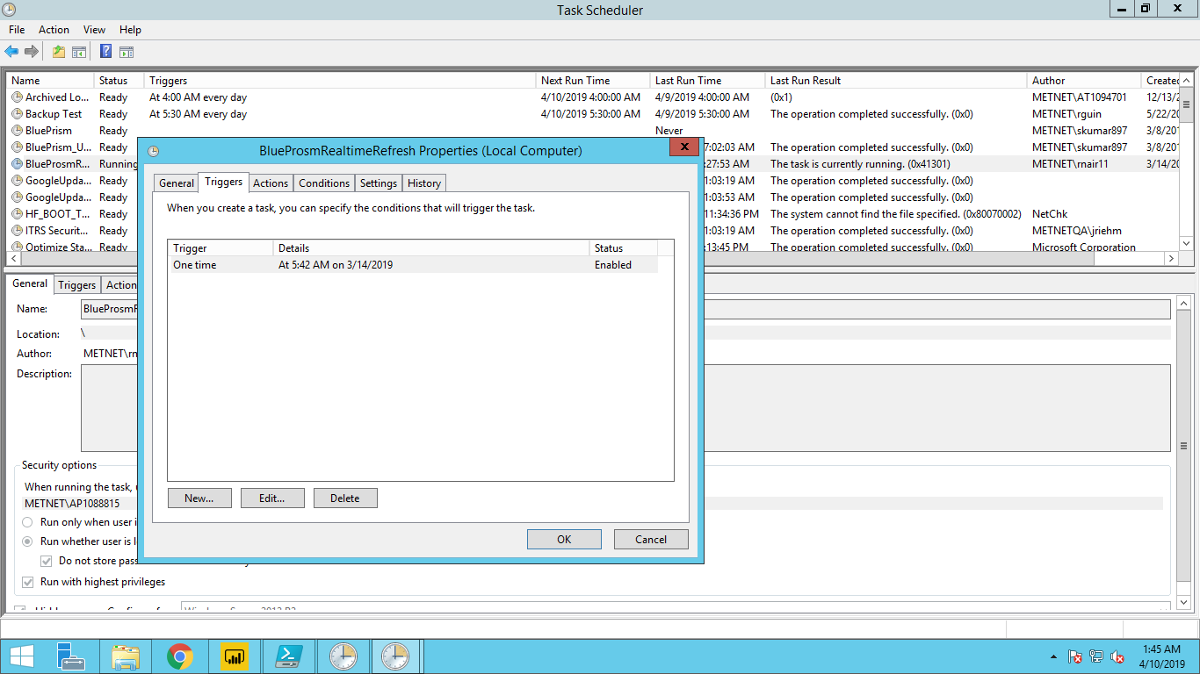

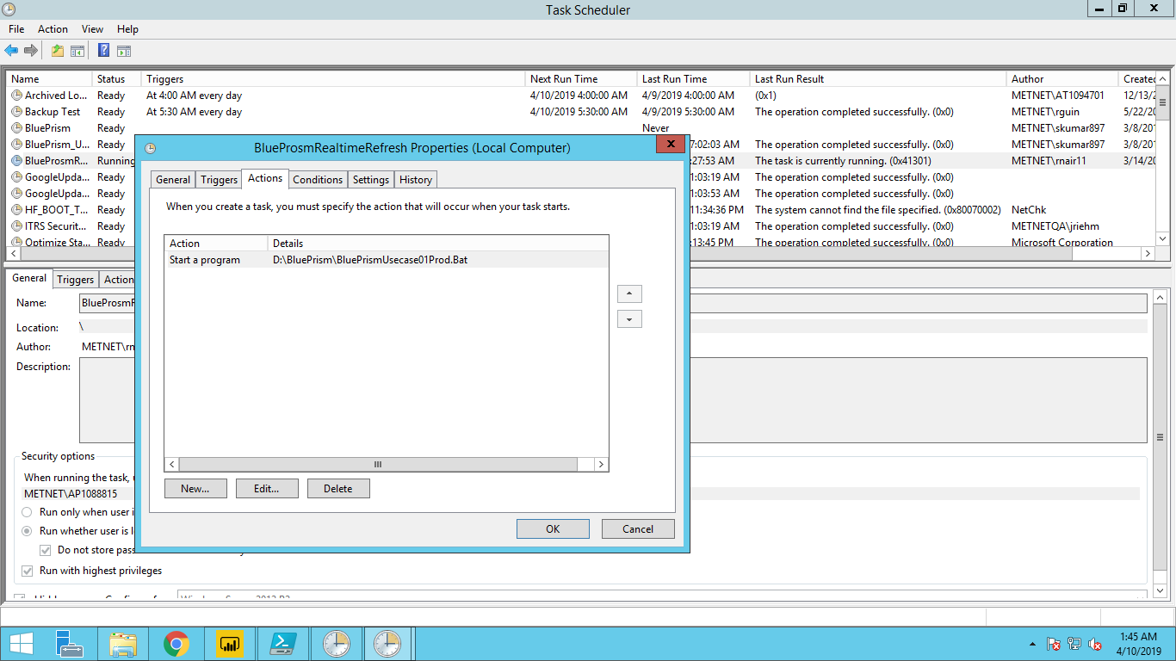

“Click on “Run” and trigger the real time refresh of datasets

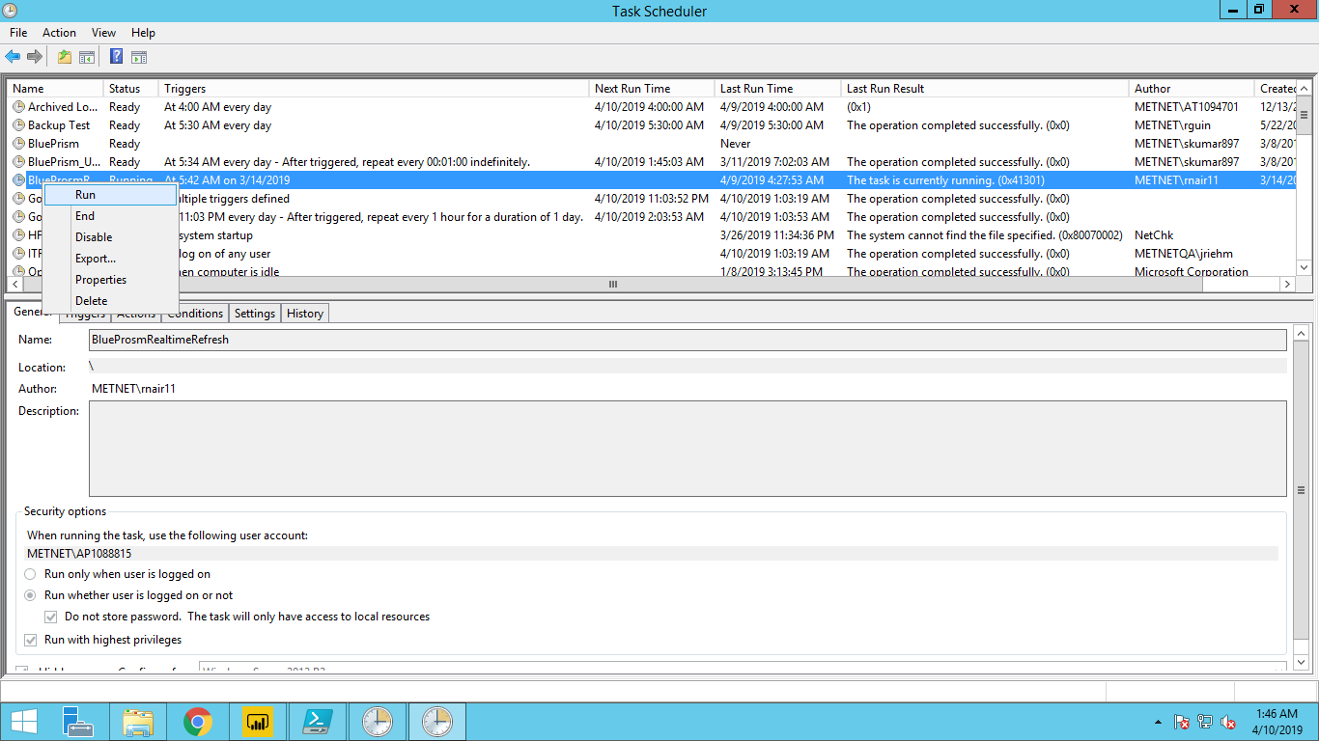

## Monitor the Powershell script

Open Task Manager

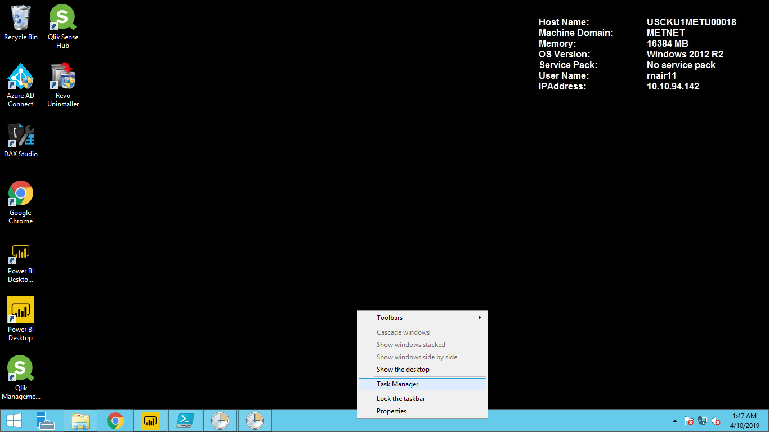

Windows Powershell ISE will be executing and the Memory and CPU usage would be displayed against the Process. This can be viewed under “Details tab also.

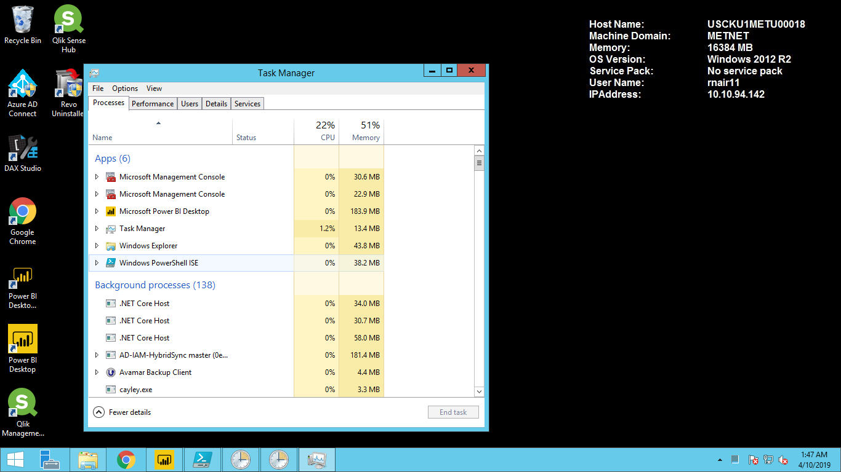

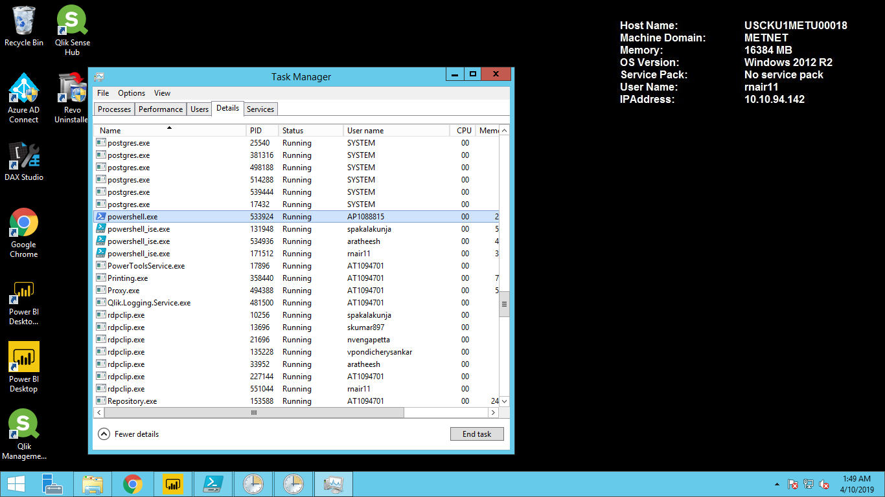

## View the report and Dashboard

Navigate to the Production workspace and click on the dashboard

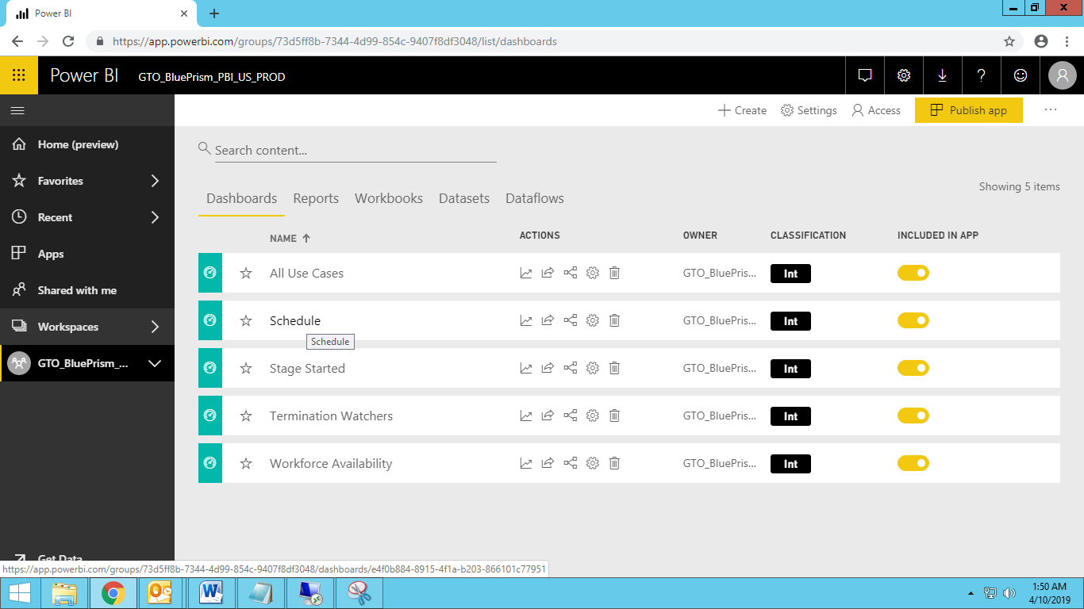

Ensure the Dashboard refreshed with latest records every 10 sec.

